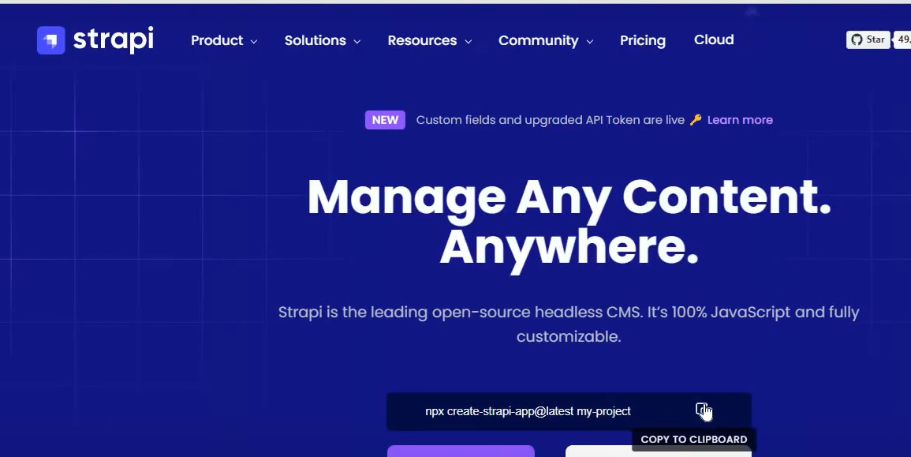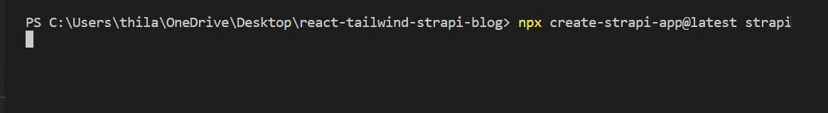

練習:

安裝React Vite環境

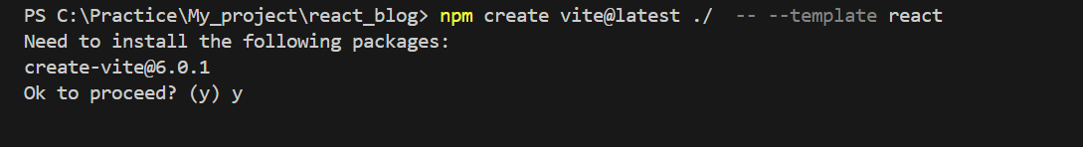

安裝strapi

<https://strapi.io/>

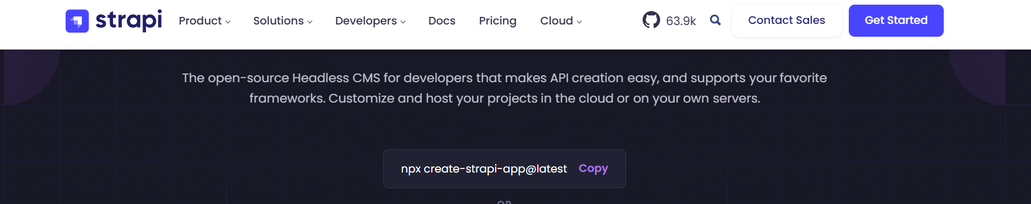

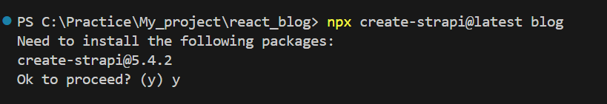

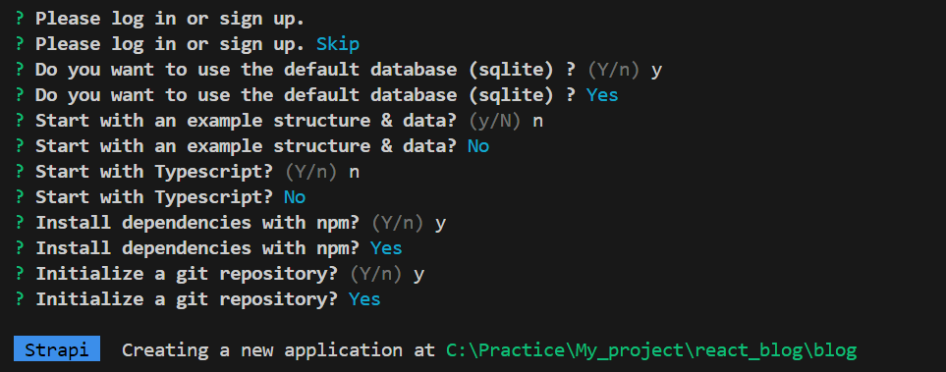



安裝完成strapi之後進入admin路由

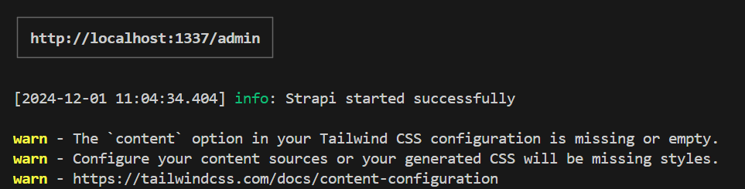

信箱:a411757@gmail

密碼:Ao81311833

成功進入admin

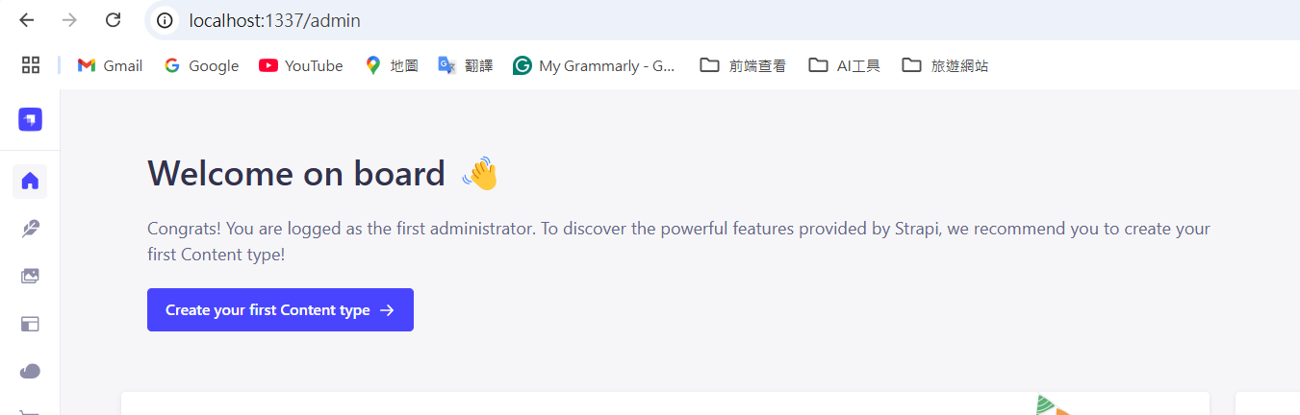

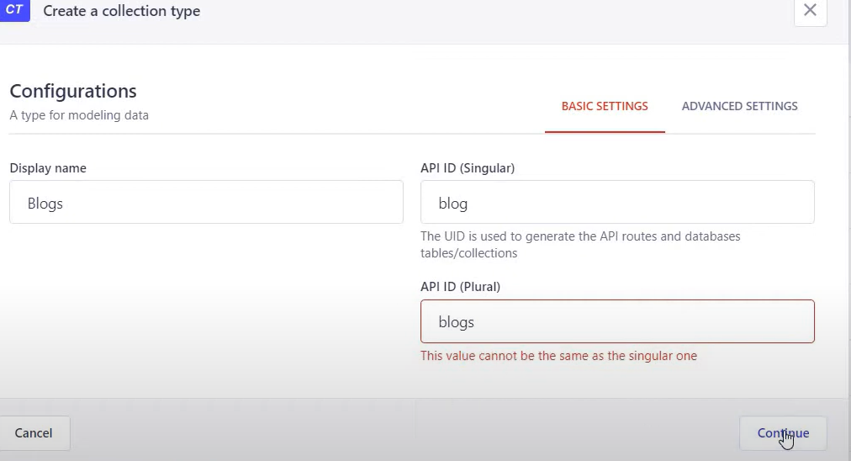 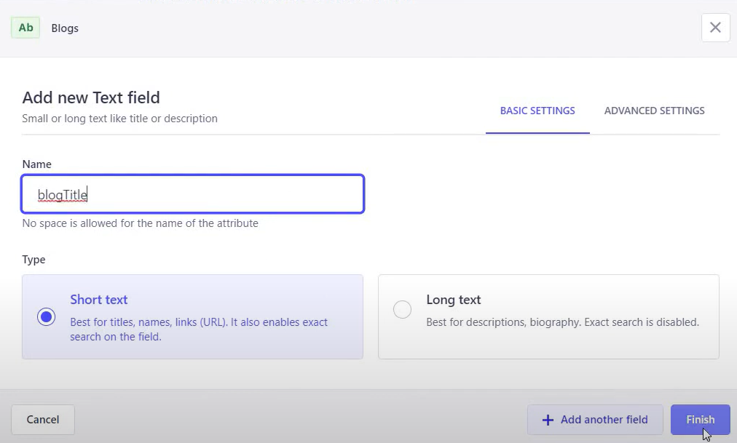

點擊



新增圖片

 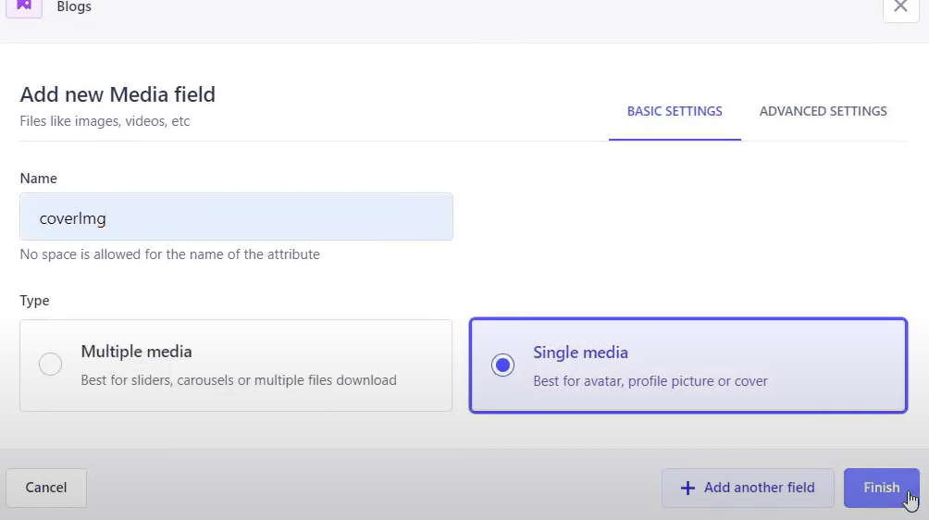

再新增Text

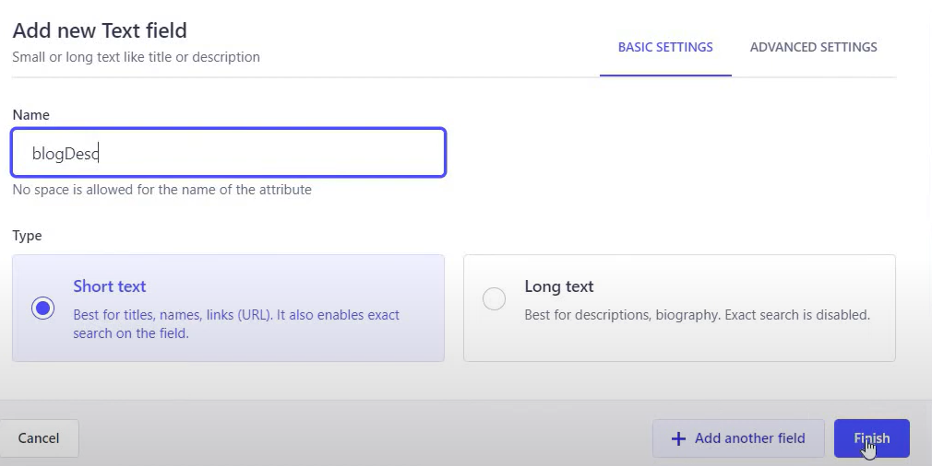

新增

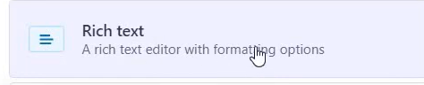 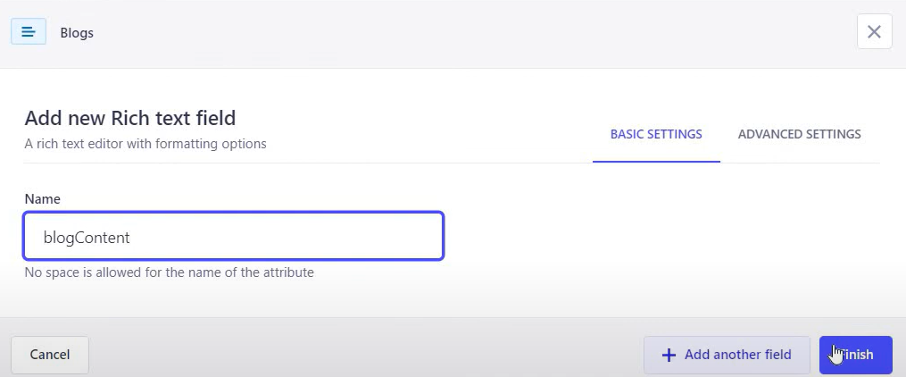

建立完成之後按右邊Save

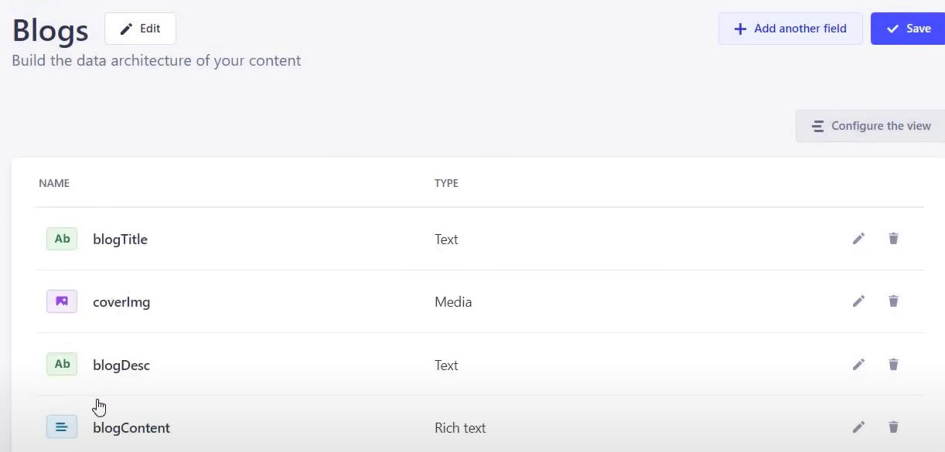

練習:

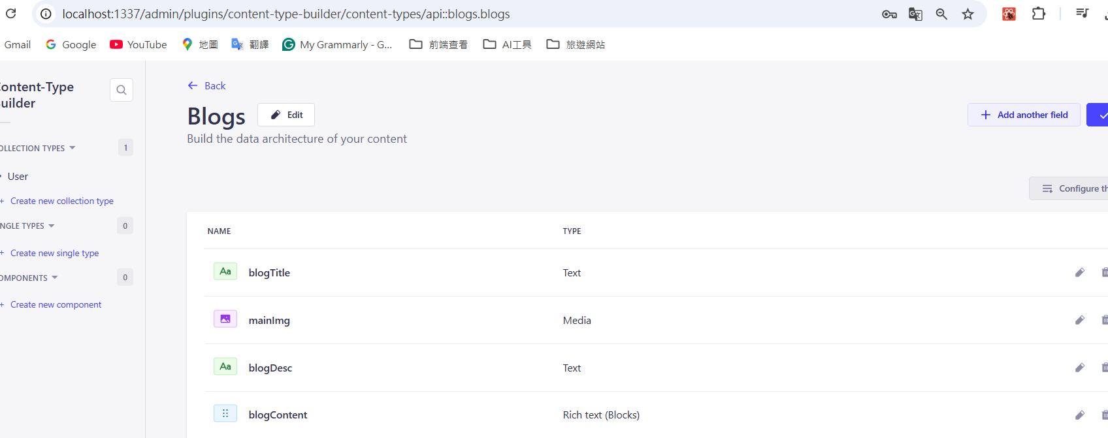

Blog.jsx使用gird母元件使用一列放入3個grid 



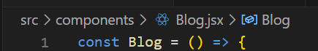

完整程式碼:

const Blog = () => {

  return (

    <div className="w-full bg-[#ece2e28f] py-[50px]">

        <div className="max-w-[1240px] mx-auto">

           <div className="grid lg:grid-cols-3 gap-8 px-4 text-black">

            <div className="bg-white rounded-xl  overflow-hidden drop-shadow-md">

                <img className="h-56 w-full object-cover" src={"https://images.unsplash.com/photo-1530789253388-582c481c54b0?w=500&auto=format&fit=crop&q=60&ixlib=rb-4.0.3&ixid=M3wxMjA3fDB8MHxzZWFyY2h8NHx8dHJhdmVsfGVufDB8fDB8fHww"} />

                <div className="p-8">

                     <h2 className="font-bold text-2xl my-1">部落格1</h2>

                     <p className="text-black text-sm">ljfgjdijfgijisdjfigjiosdjfg</p>

                </div>

            </div>

            <div className="bg-white rounded-xl  overflow-hidden drop-shadow-md">

                <img className="h-56 w-full object-cover" src={"https://images.unsplash.com/photo-1530789253388-582c481c54b0?w=500&auto=format&fit=crop&q=60&ixlib=rb-4.0.3&ixid=M3wxMjA3fDB8MHxzZWFyY2h8NHx8dHJhdmVsfGVufDB8fDB8fHww"} />

                <div className="p-8">

                     <h2 className="font-bold text-2xl my-1">部落格2</h2>

                     <p className="text-black text-sm">ljfgjdijfgijisdjfigjiosdjfg</p>

                </div>

            </div>

            <div className="bg-white rounded-xl  overflow-hidden drop-shadow-md">

                <img className="h-56 w-full object-cover" src={"https://images.unsplash.com/photo-1530789253388-582c481c54b0?w=500&auto=format&fit=crop&q=60&ixlib=rb-4.0.3&ixid=M3wxMjA3fDB8MHxzZWFyY2h8NHx8dHJhdmVsfGVufDB8fDB8fHww"} />

                <div className="p-8">

                     <h2 className="font-bold text-2xl my-1">部落格3</h2>

                     <p className="text-black text-sm">ljfgjdijfgijisdjfigjiosdjfg</p>

                </div>

            </div>

            <div className="bg-white rounded-xl  overflow-hidden drop-shadow-md">

                <img className="h-56 w-full object-cover" src={"https://images.unsplash.com/photo-1530789253388-582c481c54b0?w=500&auto=format&fit=crop&q=60&ixlib=rb-4.0.3&ixid=M3wxMjA3fDB8MHxzZWFyY2h8NHx8dHJhdmVsfGVufDB8fDB8fHww"} />

                <div className="p-8">

                     <h2 className="font-bold text-2xl my-1">部落格4</h2>

                     <p className="text-black text-sm">ljfgjdijfgijisdjfigjiosdjfg</p>

                </div>

            </div>

           </div>

        </div>

    </div>

  )

}

export default Blog

輸出:

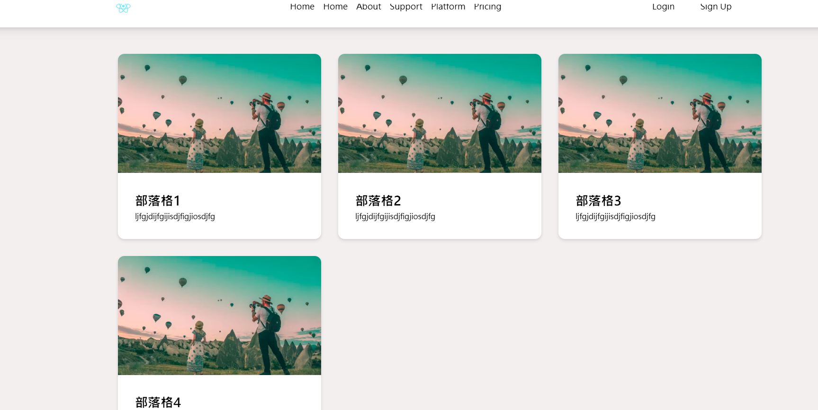

宣告變數使用陣列型態儲存blog的key和value再用map陣列方法輸出。

完整程式碼:

const Blog = () => {

     const blogs = [

        {

            "id":1,

            'title':'Blog 1',

            'desc':"Lorem Ipsum has been the industry's standard dummy text ever since the 1500s",

            'coverImg':'https://images.unsplash.com/photo-1500835556837-99ac94a94552?w=500&auto=format&fit=crop&q=60&ixlib=rb-4.0.3&ixid=M3wxMjA3fDB8MHxzZWFyY2h8M3x8dHJhdmVsfGVufDB8fDB8fHww',

            'content':'Intro to Web3 Day 1: Intro to Web3 What is Web3To put it simply, Web3 is the latest version of what we know as the internet. In this version, people have full ownership of their content, data and assets. There are also no middlemen involved, which is presently the case with large corporations and governments controlling and regulating whatever goes on the internet. In some areas, you may read some terms like decentralized and democratization of the internet being used for Web3, which can be sort of confusing. But for now, think of decentralization as not being controlled and monitored by others, rather, by yourself. Web1 = read  Web1 happened when the internet was officially introduced in the 1980s onwards. Few individuals or groups created content - like news media outlets, search engines, directories. During this era, the majority of traffic used the internet in a read-only capacity. They searched for an article, read it and closed it, that’s mostly how far it went. Very little participation. An example of Web 1 = Yahoo.comWeb2 - read, write Web2 came about in the 2000s and is still pretty much there. Now users like me and you can share our thoughts on that article we read, and that too, amongst our friends on social networks. It made space for everyone to become a content creator and consumer simultaneously - although those of us who gathered followerships only got paid. Now media is produced on social networks, who then are able to sell personal data to advertisers in order to generate massive amounts of revenue. But since they collect a lot of our personal data, privacy has started to become a concern.An example of Web2: YouTubeWeb3 - read, write, ownSince privacy and personal data became a concern, Web3 solves that. With Web3, participants will have full ownership over their content, data, and assets. It represents a democratized Internet – an Internet that is governed by users for the benefit of users. Right now everything is controlled by the people at the top - in Web3, they may not exist. Even if they do, you won’t need them because you’ll own what you create. An example of Web3: Mirror.xyz Expanding more into this, Web3 will give users full ownership of their assets, data, practically anything via blockchains. Now, what are blockchains? Blockchain is a public list of records. It stores information in batches called blocks. These blocks are linked together to form a continuous line. A chain of blocks. A blockchain. Each block is like a page of a record book. What isn’t blockchainBlockchain is NOT a cryptocurrency.Blockchain is NOT a programming language.Blockchain is NOT a cryptographic codification.Blockchain is NOT an AI or Machine Learning technology.Blockchain is NOT a Python library or framework.Nope, nada, naa. Let’s move on. But before I mention the word I’m about to,Here’s the definition for immutable: unchanging over time or unable to be changedSynonyms include: fixed - set - unchangeable - rigid - unshakeable - irremovable So, again, what does blockchain do for me?It works as an immutable (fixed, unchangeable, unshakeable) record of transactions that do not require to rely on any external authority like banks, governments, large corporations to validate the authenticity and integrity of the data. As I mentioned earlier, Blockchain is a public database of information, that means there is no central body or single entity control (say Mark Zuckerberg) managing and controlling the database and evil laughing. In fact, millions of users on the Internet help manage and maintain the records. That’s decentralized and democratized for you, hah, take that Facebook!So in a nutshell, these changes will create an open, trustless, and permissionless network. Let me explain if this sounds wild to you.Open: It will be an open-source software built by an open and accessible community of developers and executed in the full view of the world.Trustless: It will allow participants to interact publicly or privately without any third party butting in.Permissionless: Neither users nor suppliers need any authorization from a governing body for participating.If you have questions, head over to our Discord and shoot! See ya tomorrow with another bite-sized web3 lesson! 👋',

        },

        {

            "id":2,

            'title':'Blog 1',

            'desc':"Lorem Ipsum has been the industry's standard dummy text ever since the 1500s",

            'coverImg':'https://images.unsplash.com/photo-1500835556837-99ac94a94552?w=500&auto=format&fit=crop&q=60&ixlib=rb-4.0.3&ixid=M3wxMjA3fDB8MHxzZWFyY2h8M3x8dHJhdmVsfGVufDB8fDB8fHww',

            'content':'Intro to Web3 Day 1: Intro to Web3 What is Web3To put it simply, Web3 is the latest version of what we know as the internet. In this version, people have full ownership of their content, data and assets. There are also no middlemen involved, which is presently the case with large corporations and governments controlling and regulating whatever goes on the internet. In some areas, you may read some terms like decentralized and democratization of the internet being used for Web3, which can be sort of confusing. But for now, think of decentralization as not being controlled and monitored by others, rather, by yourself. Web1 = read  Web1 happened when the internet was officially introduced in the 1980s onwards. Few individuals or groups created content - like news media outlets, search engines, directories. During this era, the majority of traffic used the internet in a read-only capacity. They searched for an article, read it and closed it, that’s mostly how far it went. Very little participation. An example of Web 1 = Yahoo.comWeb2 - read, write Web2 came about in the 2000s and is still pretty much there. Now users like me and you can share our thoughts on that article we read, and that too, amongst our friends on social networks. It made space for everyone to become a content creator and consumer simultaneously - although those of us who gathered followerships only got paid. Now media is produced on social networks, who then are able to sell personal data to advertisers in order to generate massive amounts of revenue. But since they collect a lot of our personal data, privacy has started to become a concern.An example of Web2: YouTubeWeb3 - read, write, ownSince privacy and personal data became a concern, Web3 solves that. With Web3, participants will have full ownership over their content, data, and assets. It represents a democratized Internet – an Internet that is governed by users for the benefit of users. Right now everything is controlled by the people at the top - in Web3, they may not exist. Even if they do, you won’t need them because you’ll own what you create. An example of Web3: Mirror.xyz Expanding more into this, Web3 will give users full ownership of their assets, data, practically anything via blockchains. Now, what are blockchains? Blockchain is a public list of records. It stores information in batches called blocks. These blocks are linked together to form a continuous line. A chain of blocks. A blockchain. Each block is like a page of a record book. What isn’t blockchainBlockchain is NOT a cryptocurrency.Blockchain is NOT a programming language.Blockchain is NOT a cryptographic codification.Blockchain is NOT an AI or Machine Learning technology.Blockchain is NOT a Python library or framework.Nope, nada, naa. Let’s move on. But before I mention the word I’m about to,Here’s the definition for immutable: unchanging over time or unable to be changedSynonyms include: fixed - set - unchangeable - rigid - unshakeable - irremovable So, again, what does blockchain do for me?It works as an immutable (fixed, unchangeable, unshakeable) record of transactions that do not require to rely on any external authority like banks, governments, large corporations to validate the authenticity and integrity of the data. As I mentioned earlier, Blockchain is a public database of information, that means there is no central body or single entity control (say Mark Zuckerberg) managing and controlling the database and evil laughing. In fact, millions of users on the Internet help manage and maintain the records. That’s decentralized and democratized for you, hah, take that Facebook!So in a nutshell, these changes will create an open, trustless, and permissionless network. Let me explain if this sounds wild to you.Open: It will be an open-source software built by an open and accessible community of developers and executed in the full view of the world.Trustless: It will allow participants to interact publicly or privately without any third party butting in.Permissionless: Neither users nor suppliers need any authorization from a governing body for participating.If you have questions, head over to our Discord and shoot! See ya tomorrow with another bite-sized web3 lesson! 👋',

        },

        {

            "id":3,

            'title':'Blog 1',

            'desc':"Lorem Ipsum has been the industry's standard dummy text ever since the 1500s",

            'coverImg':'https://images.unsplash.com/photo-1500835556837-99ac94a94552?w=500&auto=format&fit=crop&q=60&ixlib=rb-4.0.3&ixid=M3wxMjA3fDB8MHxzZWFyY2h8M3x8dHJhdmVsfGVufDB8fDB8fHww',

            'content':'Intro to Web3 Day 1: Intro to Web3 What is Web3To put it simply, Web3 is the latest version of what we know as the internet. In this version, people have full ownership of their content, data and assets. There are also no middlemen involved, which is presently the case with large corporations and governments controlling and regulating whatever goes on the internet. In some areas, you may read some terms like decentralized and democratization of the internet being used for Web3, which can be sort of confusing. But for now, think of decentralization as not being controlled and monitored by others, rather, by yourself. Web1 = read  Web1 happened when the internet was officially introduced in the 1980s onwards. Few individuals or groups created content - like news media outlets, search engines, directories. During this era, the majority of traffic used the internet in a read-only capacity. They searched for an article, read it and closed it, that’s mostly how far it went. Very little participation. An example of Web 1 = Yahoo.comWeb2 - read, write Web2 came about in the 2000s and is still pretty much there. Now users like me and you can share our thoughts on that article we read, and that too, amongst our friends on social networks. It made space for everyone to become a content creator and consumer simultaneously - although those of us who gathered followerships only got paid. Now media is produced on social networks, who then are able to sell personal data to advertisers in order to generate massive amounts of revenue. But since they collect a lot of our personal data, privacy has started to become a concern.An example of Web2: YouTubeWeb3 - read, write, ownSince privacy and personal data became a concern, Web3 solves that. With Web3, participants will have full ownership over their content, data, and assets. It represents a democratized Internet – an Internet that is governed by users for the benefit of users. Right now everything is controlled by the people at the top - in Web3, they may not exist. Even if they do, you won’t need them because you’ll own what you create. An example of Web3: Mirror.xyz Expanding more into this, Web3 will give users full ownership of their assets, data, practically anything via blockchains. Now, what are blockchains? Blockchain is a public list of records. It stores information in batches called blocks. These blocks are linked together to form a continuous line. A chain of blocks. A blockchain. Each block is like a page of a record book. What isn’t blockchainBlockchain is NOT a cryptocurrency.Blockchain is NOT a programming language.Blockchain is NOT a cryptographic codification.Blockchain is NOT an AI or Machine Learning technology.Blockchain is NOT a Python library or framework.Nope, nada, naa. Let’s move on. But before I mention the word I’m about to,Here’s the definition for immutable: unchanging over time or unable to be changedSynonyms include: fixed - set - unchangeable - rigid - unshakeable - irremovable So, again, what does blockchain do for me?It works as an immutable (fixed, unchangeable, unshakeable) record of transactions that do not require to rely on any external authority like banks, governments, large corporations to validate the authenticity and integrity of the data. As I mentioned earlier, Blockchain is a public database of information, that means there is no central body or single entity control (say Mark Zuckerberg) managing and controlling the database and evil laughing. In fact, millions of users on the Internet help manage and maintain the records. That’s decentralized and democratized for you, hah, take that Facebook!So in a nutshell, these changes will create an open, trustless, and permissionless network. Let me explain if this sounds wild to you.Open: It will be an open-source software built by an open and accessible community of developers and executed in the full view of the world.Trustless: It will allow participants to interact publicly or privately without any third party butting in.Permissionless: Neither users nor suppliers need any authorization from a governing body for participating.If you have questions, head over to our Discord and shoot! See ya tomorrow with another bite-sized web3 lesson! 👋',

        },

        {

            "id":4,

            'title':'Blog 1',

            'desc':"Lorem Ipsum has been the industry's standard dummy text ever since the 1500s",

            'coverImg':'https://images.unsplash.com/photo-1500835556837-99ac94a94552?w=500&auto=format&fit=crop&q=60&ixlib=rb-4.0.3&ixid=M3wxMjA3fDB8MHxzZWFyY2h8M3x8dHJhdmVsfGVufDB8fDB8fHww',

            'content':'Intro to Web3 Day 1: Intro to Web3 What is Web3To put it simply, Web3 is the latest version of what we know as the internet. In this version, people have full ownership of their content, data and assets. There are also no middlemen involved, which is presently the case with large corporations and governments controlling and regulating whatever goes on the internet. In some areas, you may read some terms like decentralized and democratization of the internet being used for Web3, which can be sort of confusing. But for now, think of decentralization as not being controlled and monitored by others, rather, by yourself. Web1 = read  Web1 happened when the internet was officially introduced in the 1980s onwards. Few individuals or groups created content - like news media outlets, search engines, directories. During this era, the majority of traffic used the internet in a read-only capacity. They searched for an article, read it and closed it, that’s mostly how far it went. Very little participation. An example of Web 1 = Yahoo.comWeb2 - read, write Web2 came about in the 2000s and is still pretty much there. Now users like me and you can share our thoughts on that article we read, and that too, amongst our friends on social networks. It made space for everyone to become a content creator and consumer simultaneously - although those of us who gathered followerships only got paid. Now media is produced on social networks, who then are able to sell personal data to advertisers in order to generate massive amounts of revenue. But since they collect a lot of our personal data, privacy has started to become a concern.An example of Web2: YouTubeWeb3 - read, write, ownSince privacy and personal data became a concern, Web3 solves that. With Web3, participants will have full ownership over their content, data, and assets. It represents a democratized Internet – an Internet that is governed by users for the benefit of users. Right now everything is controlled by the people at the top - in Web3, they may not exist. Even if they do, you won’t need them because you’ll own what you create. An example of Web3: Mirror.xyz Expanding more into this, Web3 will give users full ownership of their assets, data, practically anything via blockchains. Now, what are blockchains? Blockchain is a public list of records. It stores information in batches called blocks. These blocks are linked together to form a continuous line. A chain of blocks. A blockchain. Each block is like a page of a record book. What isn’t blockchainBlockchain is NOT a cryptocurrency.Blockchain is NOT a programming language.Blockchain is NOT a cryptographic codification.Blockchain is NOT an AI or Machine Learning technology.Blockchain is NOT a Python library or framework.Nope, nada, naa. Let’s move on. But before I mention the word I’m about to,Here’s the definition for immutable: unchanging over time or unable to be changedSynonyms include: fixed - set - unchangeable - rigid - unshakeable - irremovable So, again, what does blockchain do for me?It works as an immutable (fixed, unchangeable, unshakeable) record of transactions that do not require to rely on any external authority like banks, governments, large corporations to validate the authenticity and integrity of the data. As I mentioned earlier, Blockchain is a public database of information, that means there is no central body or single entity control (say Mark Zuckerberg) managing and controlling the database and evil laughing. In fact, millions of users on the Internet help manage and maintain the records. That’s decentralized and democratized for you, hah, take that Facebook!So in a nutshell, these changes will create an open, trustless, and permissionless network. Let me explain if this sounds wild to you.Open: It will be an open-source software built by an open and accessible community of developers and executed in the full view of the world.Trustless: It will allow participants to interact publicly or privately without any third party butting in.Permissionless: Neither users nor suppliers need any authorization from a governing body for participating.If you have questions, head over to our Discord and shoot! See ya tomorrow with another bite-sized web3 lesson! 👋',

        },

        {

            "id":5,

            'title':'Blog 1',

            'desc':"Lorem Ipsum has been the industry's standard dummy text ever since the 1500s",

            'coverImg':'https://images.unsplash.com/photo-1500835556837-99ac94a94552?w=500&auto=format&fit=crop&q=60&ixlib=rb-4.0.3&ixid=M3wxMjA3fDB8MHxzZWFyY2h8M3x8dHJhdmVsfGVufDB8fDB8fHww',

            'content':'Intro to Web3 Day 1: Intro to Web3 What is Web3To put it simply, Web3 is the latest version of what we know as the internet. In this version, people have full ownership of their content, data and assets. There are also no middlemen involved, which is presently the case with large corporations and governments controlling and regulating whatever goes on the internet. In some areas, you may read some terms like decentralized and democratization of the internet being used for Web3, which can be sort of confusing. But for now, think of decentralization as not being controlled and monitored by others, rather, by yourself. Web1 = read  Web1 happened when the internet was officially introduced in the 1980s onwards. Few individuals or groups created content - like news media outlets, search engines, directories. During this era, the majority of traffic used the internet in a read-only capacity. They searched for an article, read it and closed it, that’s mostly how far it went. Very little participation. An example of Web 1 = Yahoo.comWeb2 - read, write Web2 came about in the 2000s and is still pretty much there. Now users like me and you can share our thoughts on that article we read, and that too, amongst our friends on social networks. It made space for everyone to become a content creator and consumer simultaneously - although those of us who gathered followerships only got paid. Now media is produced on social networks, who then are able to sell personal data to advertisers in order to generate massive amounts of revenue. But since they collect a lot of our personal data, privacy has started to become a concern.An example of Web2: YouTubeWeb3 - read, write, ownSince privacy and personal data became a concern, Web3 solves that. With Web3, participants will have full ownership over their content, data, and assets. It represents a democratized Internet – an Internet that is governed by users for the benefit of users. Right now everything is controlled by the people at the top - in Web3, they may not exist. Even if they do, you won’t need them because you’ll own what you create. An example of Web3: Mirror.xyz Expanding more into this, Web3 will give users full ownership of their assets, data, practically anything via blockchains. Now, what are blockchains? Blockchain is a public list of records. It stores information in batches called blocks. These blocks are linked together to form a continuous line. A chain of blocks. A blockchain. Each block is like a page of a record book. What isn’t blockchainBlockchain is NOT a cryptocurrency.Blockchain is NOT a programming language.Blockchain is NOT a cryptographic codification.Blockchain is NOT an AI or Machine Learning technology.Blockchain is NOT a Python library or framework.Nope, nada, naa. Let’s move on. But before I mention the word I’m about to,Here’s the definition for immutable: unchanging over time or unable to be changedSynonyms include: fixed - set - unchangeable - rigid - unshakeable - irremovable So, again, what does blockchain do for me?It works as an immutable (fixed, unchangeable, unshakeable) record of transactions that do not require to rely on any external authority like banks, governments, large corporations to validate the authenticity and integrity of the data. As I mentioned earlier, Blockchain is a public database of information, that means there is no central body or single entity control (say Mark Zuckerberg) managing and controlling the database and evil laughing. In fact, millions of users on the Internet help manage and maintain the records. That’s decentralized and democratized for you, hah, take that Facebook!So in a nutshell, these changes will create an open, trustless, and permissionless network. Let me explain if this sounds wild to you.Open: It will be an open-source software built by an open and accessible community of developers and executed in the full view of the world.Trustless: It will allow participants to interact publicly or privately without any third party butting in.Permissionless: Neither users nor suppliers need any authorization from a governing body for participating.If you have questions, head over to our Discord and shoot! See ya tomorrow with another bite-sized web3 lesson! 👋',

        },

        {

            "id":6,

            'title':'Blog 1',

            'desc':"Lorem Ipsum has been the industry's standard dummy text ever since the 1500s",

            'coverImg':'https://images.unsplash.com/photo-1500835556837-99ac94a94552?w=500&auto=format&fit=crop&q=60&ixlib=rb-4.0.3&ixid=M3wxMjA3fDB8MHxzZWFyY2h8M3x8dHJhdmVsfGVufDB8fDB8fHww',

            'content':'Intro to Web3 Day 1: Intro to Web3 What is Web3To put it simply, Web3 is the latest version of what we know as the internet. In this version, people have full ownership of their content, data and assets. There are also no middlemen involved, which is presently the case with large corporations and governments controlling and regulating whatever goes on the internet. In some areas, you may read some terms like decentralized and democratization of the internet being used for Web3, which can be sort of confusing. But for now, think of decentralization as not being controlled and monitored by others, rather, by yourself. Web1 = read  Web1 happened when the internet was officially introduced in the 1980s onwards. Few individuals or groups created content - like news media outlets, search engines, directories. During this era, the majority of traffic used the internet in a read-only capacity. They searched for an article, read it and closed it, that’s mostly how far it went. Very little participation. An example of Web 1 = Yahoo.comWeb2 - read, write Web2 came about in the 2000s and is still pretty much there. Now users like me and you can share our thoughts on that article we read, and that too, amongst our friends on social networks. It made space for everyone to become a content creator and consumer simultaneously - although those of us who gathered followerships only got paid. Now media is produced on social networks, who then are able to sell personal data to advertisers in order to generate massive amounts of revenue. But since they collect a lot of our personal data, privacy has started to become a concern.An example of Web2: YouTubeWeb3 - read, write, ownSince privacy and personal data became a concern, Web3 solves that. With Web3, participants will have full ownership over their content, data, and assets. It represents a democratized Internet – an Internet that is governed by users for the benefit of users. Right now everything is controlled by the people at the top - in Web3, they may not exist. Even if they do, you won’t need them because you’ll own what you create. An example of Web3: Mirror.xyz Expanding more into this, Web3 will give users full ownership of their assets, data, practically anything via blockchains. Now, what are blockchains? Blockchain is a public list of records. It stores information in batches called blocks. These blocks are linked together to form a continuous line. A chain of blocks. A blockchain. Each block is like a page of a record book. What isn’t blockchainBlockchain is NOT a cryptocurrency.Blockchain is NOT a programming language.Blockchain is NOT a cryptographic codification.Blockchain is NOT an AI or Machine Learning technology.Blockchain is NOT a Python library or framework.Nope, nada, naa. Let’s move on. But before I mention the word I’m about to,Here’s the definition for immutable: unchanging over time or unable to be changedSynonyms include: fixed - set - unchangeable - rigid - unshakeable - irremovable So, again, what does blockchain do for me?It works as an immutable (fixed, unchangeable, unshakeable) record of transactions that do not require to rely on any external authority like banks, governments, large corporations to validate the authenticity and integrity of the data. As I mentioned earlier, Blockchain is a public database of information, that means there is no central body or single entity control (say Mark Zuckerberg) managing and controlling the database and evil laughing. In fact, millions of users on the Internet help manage and maintain the records. That’s decentralized and democratized for you, hah, take that Facebook!So in a nutshell, these changes will create an open, trustless, and permissionless network. Let me explain if this sounds wild to you.Open: It will be an open-source software built by an open and accessible community of developers and executed in the full view of the world.Trustless: It will allow participants to interact publicly or privately without any third party butting in.Permissionless: Neither users nor suppliers need any authorization from a governing body for participating.If you have questions, head over to our Discord and shoot! See ya tomorrow with another bite-sized web3 lesson! 👋',

        },

     ]

  return (

    <div className="w-full bg-[#ece2e28f] py-[50px]">

        <div className="max-w-[1240px] mx-auto">

           <div className="grid lg:grid-cols-3 md:grid-cols-2 gap-8 px-4 text-black">

            {blogs.map((blog)=>

              <div key={blog.id}className="bg-white rounded-xl  overflow-hidden drop-shadow-md">

              <img className="h-56 w-full object-cover" src={blog.coverImg} />

              <div className="p-8">

                   <h2 className="font-bold text-2xl my-1">{blog.title}</h2>

                   <p className="text-black text-sm">{blog.desc}</p>

              </div>

          </div>

            )}

           </div>

        </div>

    </div>

  )

}

export default Blog

md:為中螢幕裝置的時候設定grid-cols-2一列只有兩個圖片，所以最大螢幕裝置的時候一列有三個圖片



輸出:

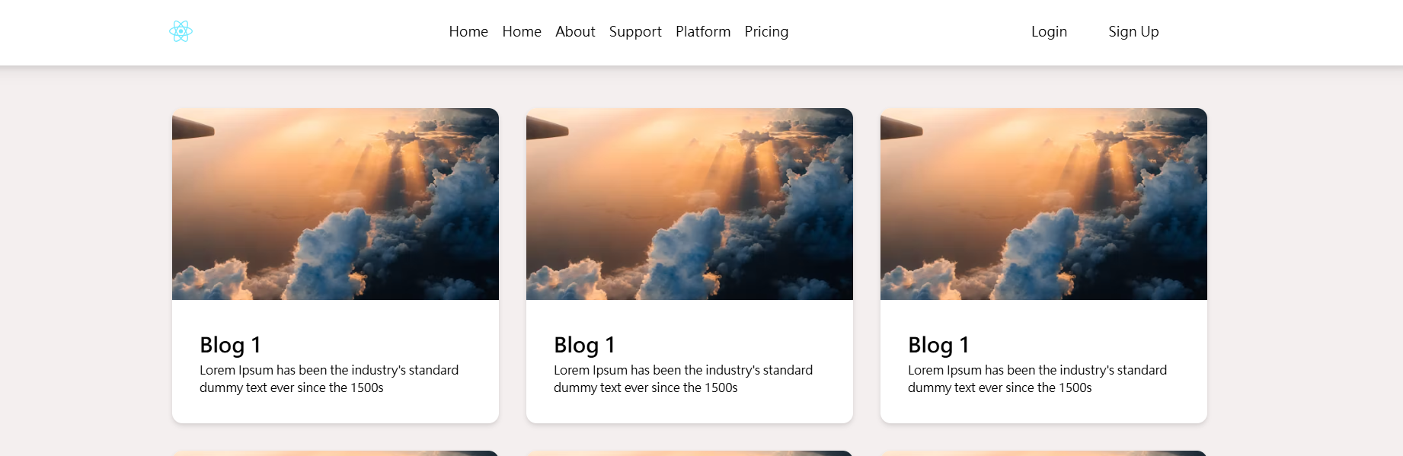 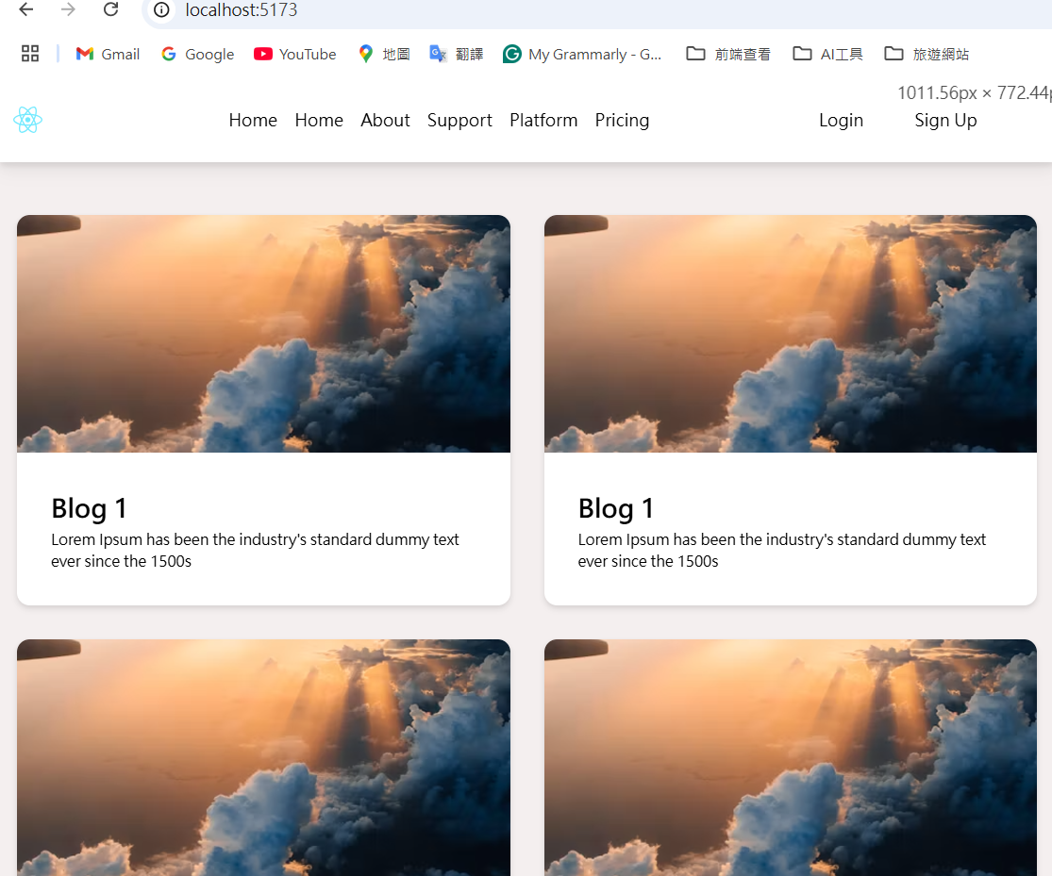

也設定sm螢幕寬度較小的裝置為一列只有兩個圖片

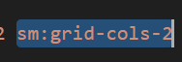

路由:

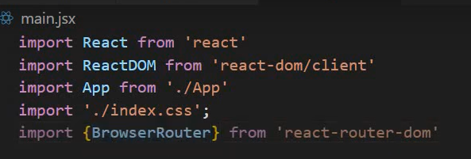

包住App.jsx

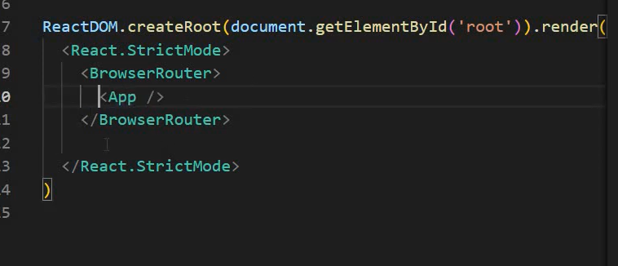

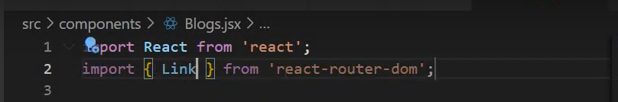

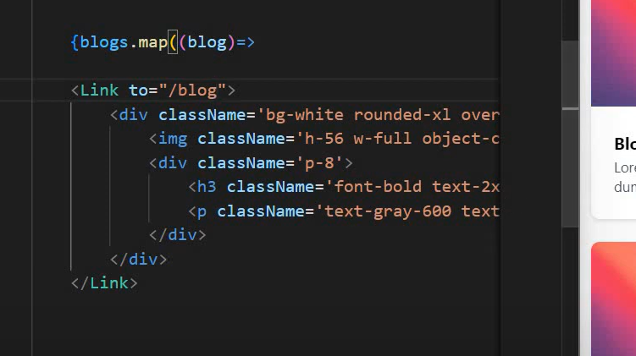

這邊希望點blog 1的時候進入blog路由/1，動態id路由。

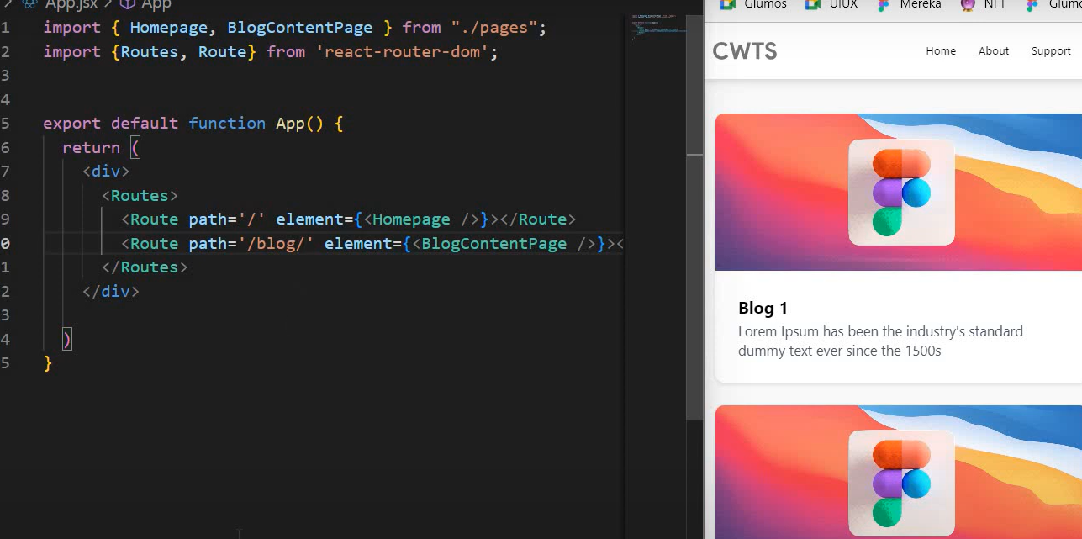

App.jsx使用關鍵字:id

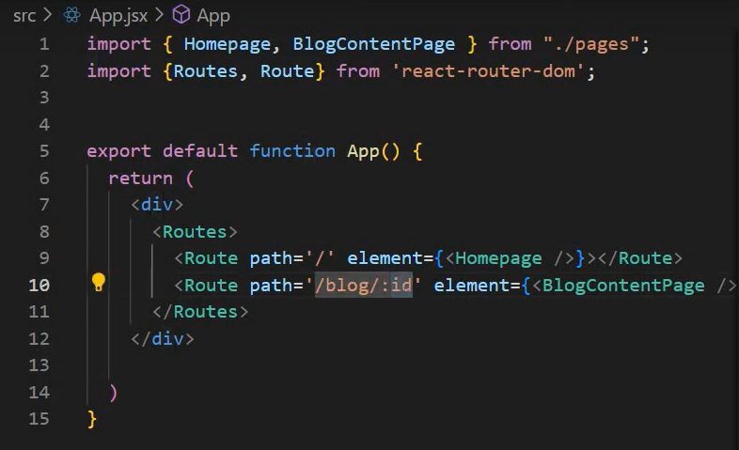

Blog.jsx 用Link元件to 動態id路徑

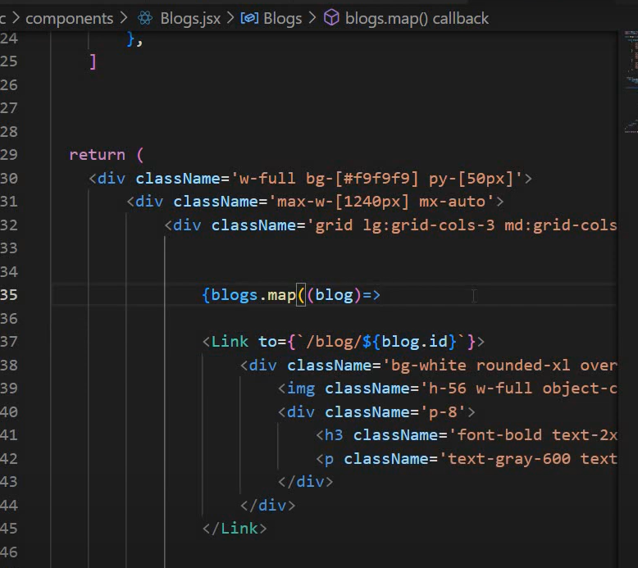

練習:

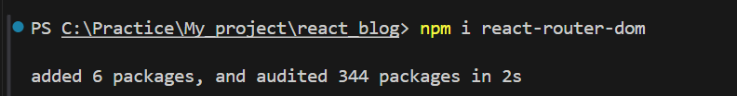

安裝完成路由之後main.jsx引入BrowerRouter元件包住App

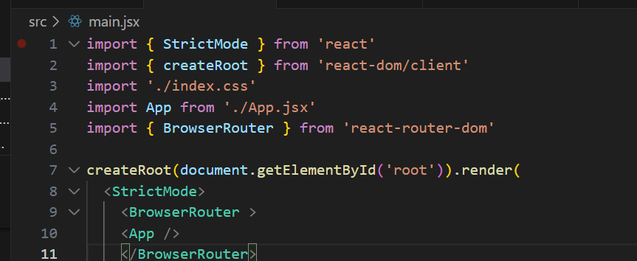

建立Homepage引入Navbar, Blog元件

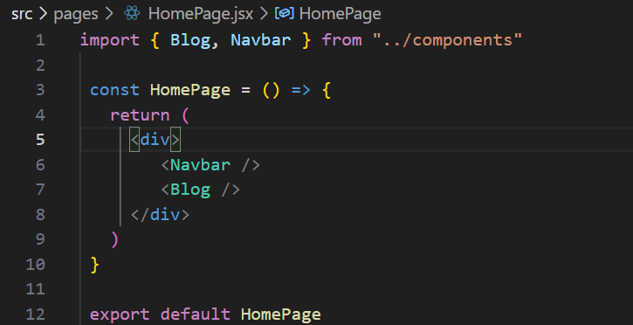

App.jsx引入Routes, Route路由

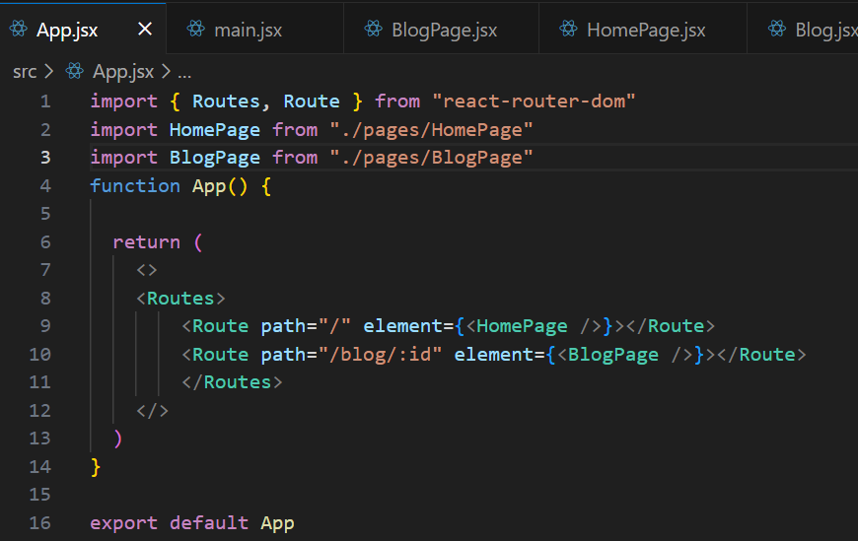

建立BlogPage.jsx元件當使用者點擊Blog1的時候會對應到相對應的id路由。

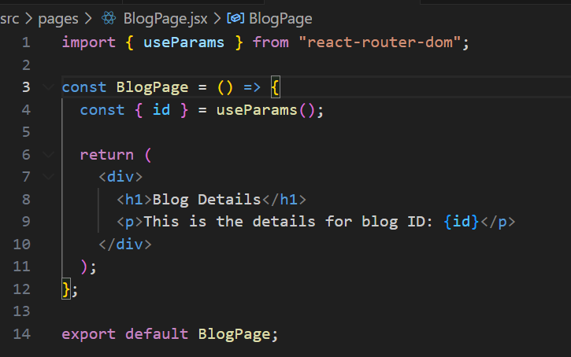

輸出: 假設我要點Blog3

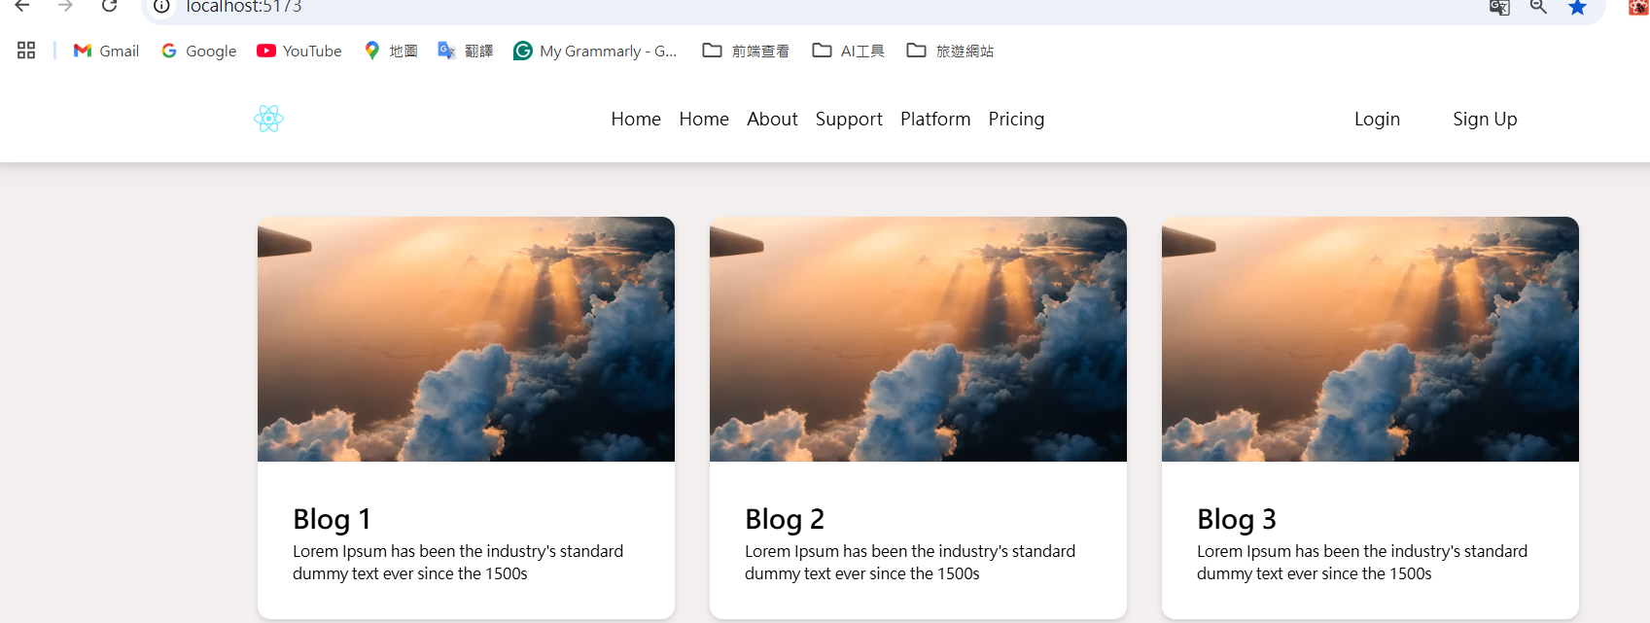

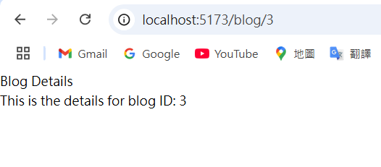

BlogPage輸出內容:

Blogs變數用find陣列方法去抓取符合相同ID的內容

import { useParams } from "react-router-dom";

const BlogPage = () => {

  const { id } = useParams();

  const blogs = [

    {

      id: 1,

      title: "Blog 1",

      desc: "Lorem Ipsum has been the industry's standard dummy text ever since the 1500s",

      coverImg:

        "https://images.unsplash.com/photo-1500835556837-99ac94a94552?w=500&auto=format&fit=crop&q=60&ixlib=rb-4.0.3&ixid=M3wxMjA3fDB8MHxzZWFyY2h8M3x8dHJhdmVsfGVufDB8fDB8fHww",

    },

    {

        id: 2,

        title: "Blog 2",

        desc: "Lorem Ipsum has been the industry's standard dummy text ever since the 1500s",

        coverImg:

          "https://images.unsplash.com/photo-1500835556837-99ac94a94552?w=500&auto=format&fit=crop&q=60&ixlib=rb-4.0.3&ixid=M3wxMjA3fDB8MHxzZWFyY2h8M3x8dHJhdmVsfGVufDB8fDB8fHww",

      },

      {

        id: 3,

        title: "Blog 3",

        desc: "Lorem Ipsum has been the industry's standard dummy text ever since the 1500s",

        coverImg:

          "https://images.unsplash.com/photo-1500835556837-99ac94a94552?w=500&auto=format&fit=crop&q=60&ixlib=rb-4.0.3&ixid=M3wxMjA3fDB8MHxzZWFyY2h8M3x8dHJhdmVsfGVufDB8fDB8fHww",

      },

      {

        id: 4,

        title: "Blog 4",

        desc: "Lorem Ipsum has been the industry's standard dummy text ever since the 1500s",

        coverImg:

          "https://images.unsplash.com/photo-1500835556837-99ac94a94552?w=500&auto=format&fit=crop&q=60&ixlib=rb-4.0.3&ixid=M3wxMjA3fDB8MHxzZWFyY2h8M3x8dHJhdmVsfGVufDB8fDB8fHww",

      },

      {

        id: 5,

        title: "Blog 5",

        desc: "Lorem Ipsum has been the industry's standard dummy text ever since the 1500s",

        coverImg:

          "https://images.unsplash.com/photo-1500835556837-99ac94a94552?w=500&auto=format&fit=crop&q=60&ixlib=rb-4.0.3&ixid=M3wxMjA3fDB8MHxzZWFyY2h8M3x8dHJhdmVsfGVufDB8fDB8fHww",

      },

      {

        id: 6,

        title: "Blog 6",

        desc: "Lorem Ipsum has been the industry's standard dummy text ever since the 1500s",

        coverImg:

          "https://images.unsplash.com/photo-1500835556837-99ac94a94552?w=500&auto=format&fit=crop&q=60&ixlib=rb-4.0.3&ixid=M3wxMjA3fDB8MHxzZWFyY2h8M3x8dHJhdmVsfGVufDB8fDB8fHww",

      },

  ];

  const blog = blogs.find(blog => blog.id === Number(id));

 return(

    <div>

   <img

     className="h-56 w-full object-cover"

     src={blog.coverImg}

     alt={`Cover for ${blog.title}`}

   />

   <div className="p-8">

     <h2 className="font-bold text-2xl my-1">{blog.title}</h2>

     <p className="text-black text-sm">{blog.desc}</p>

   </div>

 </div>

  );

};

export default BlogPage;

輸出:

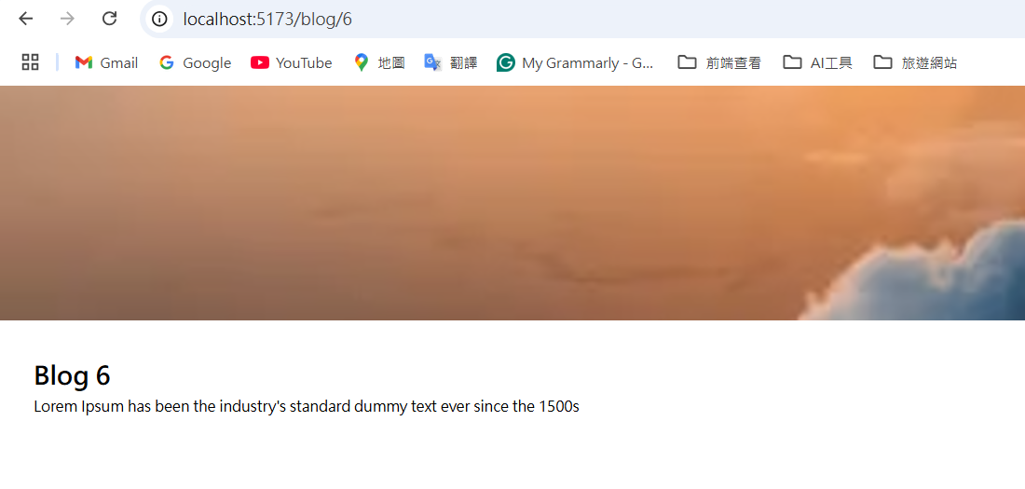

Blog.jsx完整程式碼:

import { Link } from "react-router-dom";

const Blog = () => {

  const blogs = [

    {

      id: 1,

      title: "Blog 1",

      desc: "Lorem Ipsum has been the industry's standard dummy text ever since the 1500s",

      coverImg:

        "https://images.unsplash.com/photo-1500835556837-99ac94a94552?w=500&auto=format&fit=crop&q=60&ixlib=rb-4.0.3&ixid=M3wxMjA3fDB8MHxzZWFyY2h8M3x8dHJhdmVsfGVufDB8fDB8fHww",

    },

    {

        id: 2,

        title: "Blog 2",

        desc: "Lorem Ipsum has been the industry's standard dummy text ever since the 1500s",

        coverImg:

          "https://images.unsplash.com/photo-1500835556837-99ac94a94552?w=500&auto=format&fit=crop&q=60&ixlib=rb-4.0.3&ixid=M3wxMjA3fDB8MHxzZWFyY2h8M3x8dHJhdmVsfGVufDB8fDB8fHww",

      },

      {

        id: 3,

        title: "Blog 3",

        desc: "Lorem Ipsum has been the industry's standard dummy text ever since the 1500s",

        coverImg:

          "https://images.unsplash.com/photo-1500835556837-99ac94a94552?w=500&auto=format&fit=crop&q=60&ixlib=rb-4.0.3&ixid=M3wxMjA3fDB8MHxzZWFyY2h8M3x8dHJhdmVsfGVufDB8fDB8fHww",

      },

      {

        id: 4,

        title: "Blog 4",

        desc: "Lorem Ipsum has been the industry's standard dummy text ever since the 1500s",

        coverImg:

          "https://images.unsplash.com/photo-1500835556837-99ac94a94552?w=500&auto=format&fit=crop&q=60&ixlib=rb-4.0.3&ixid=M3wxMjA3fDB8MHxzZWFyY2h8M3x8dHJhdmVsfGVufDB8fDB8fHww",

      },

      {

        id: 5,

        title: "Blog 5",

        desc: "Lorem Ipsum has been the industry's standard dummy text ever since the 1500s",

        coverImg:

          "https://images.unsplash.com/photo-1500835556837-99ac94a94552?w=500&auto=format&fit=crop&q=60&ixlib=rb-4.0.3&ixid=M3wxMjA3fDB8MHxzZWFyY2h8M3x8dHJhdmVsfGVufDB8fDB8fHww",

      },

      {

        id: 6,

        title: "Blog 6",

        desc: "Lorem Ipsum has been the industry's standard dummy text ever since the 1500s",

        coverImg:

          "https://images.unsplash.com/photo-1500835556837-99ac94a94552?w=500&auto=format&fit=crop&q=60&ixlib=rb-4.0.3&ixid=M3wxMjA3fDB8MHxzZWFyY2h8M3x8dHJhdmVsfGVufDB8fDB8fHww",

      },

  ];

  return (

    <div className="w-full bg-[#ece2e28f] py-[50px]">

      <div className="max-w-[1240px] mx-auto">

        <div className="grid lg:grid-cols-3 md:grid-cols-2 sm:grid-cols-2 gap-8 px-4 text-black">

          {blogs.map((blog) => (

            <Link to={`/blog/${blog.id}`} key={blog.id}>

              <div className="bg-white rounded-xl overflow-hidden drop-shadow-md">

                <img

                  className="h-56 w-full object-cover"

                  src={blog.coverImg}

                  alt={`Cover for ${blog.title}`}

                />

                <div className="p-8">

                  <h2 className="font-bold text-2xl my-1">{blog.title}</h2>

                  <p className="text-black text-sm">{blog.desc}</p>

                </div>

              </div>

            </Link>

          ))}

        </div>

      </div>

    </div>

  );

};

export default Blog;

BlogPage.jsx完整程式碼:

import { useParams } from "react-router-dom";

import { Navbar } from "../components";

const BlogPage = () => {

  const { id } = useParams();

  const blogs = [

    {

      id: 1,

      title: "Blog 1",

      desc: "Lorem Ipsum has been the industry's standard dummy text ever since the 1500s",

      coverImg:

        "https://images.unsplash.com/photo-1500835556837-99ac94a94552?w=500&auto=format&fit=crop&q=60&ixlib=rb-4.0.3&ixid=M3wxMjA3fDB8MHxzZWFyY2h8M3x8dHJhdmVsfGVufDB8fDB8fHww",

    },

    {

        id: 2,

        title: "Blog 2",

        desc: "Lorem Ipsum has been the industry's standard dummy text ever since the 1500s",

        coverImg:

          "https://images.unsplash.com/photo-1500835556837-99ac94a94552?w=500&auto=format&fit=crop&q=60&ixlib=rb-4.0.3&ixid=M3wxMjA3fDB8MHxzZWFyY2h8M3x8dHJhdmVsfGVufDB8fDB8fHww",

      },

      {

        id: 3,

        title: "Blog 3",

        desc: "Lorem Ipsum has been the industry's standard dummy text ever since the 1500s",

        coverImg:

          "https://images.unsplash.com/photo-1500835556837-99ac94a94552?w=500&auto=format&fit=crop&q=60&ixlib=rb-4.0.3&ixid=M3wxMjA3fDB8MHxzZWFyY2h8M3x8dHJhdmVsfGVufDB8fDB8fHww",

      },

      {

        id: 4,

        title: "Blog 4",

        desc: "Lorem Ipsum has been the industry's standard dummy text ever since the 1500s",

        coverImg:

          "https://images.unsplash.com/photo-1500835556837-99ac94a94552?w=500&auto=format&fit=crop&q=60&ixlib=rb-4.0.3&ixid=M3wxMjA3fDB8MHxzZWFyY2h8M3x8dHJhdmVsfGVufDB8fDB8fHww",

      },

      {

        id: 5,

        title: "Blog 5",

        desc: "Lorem Ipsum has been the industry's standard dummy text ever since the 1500s",

        coverImg:

          "https://images.unsplash.com/photo-1500835556837-99ac94a94552?w=500&auto=format&fit=crop&q=60&ixlib=rb-4.0.3&ixid=M3wxMjA3fDB8MHxzZWFyY2h8M3x8dHJhdmVsfGVufDB8fDB8fHww",

      },

      {

        id: 6,

        title: "Blog 6",

        desc: "Lorem Ipsum has been the industry's standard dummy text ever since the 1500s",

        coverImg:

          "https://images.unsplash.com/photo-1500835556837-99ac94a94552?w=500&auto=format&fit=crop&q=60&ixlib=rb-4.0.3&ixid=M3wxMjA3fDB8MHxzZWFyY2h8M3x8dHJhdmVsfGVufDB8fDB8fHww",

      },

  ];

  const blog = blogs.find(blog => blog.id === Number(id));

 return(

    <div>

        <Navbar />

   <img

     className="h-56 w-full object-cover"

     src={blog.coverImg}

     alt={`Cover for ${blog.title}`}

   />

   <div className="p-8">

     <h2 className="font-bold text-2xl my-1">{blog.title}</h2>

     <p className="text-black text-sm">{blog.desc}</p>

   </div>

 </div>

  );

};

export default BlogPage;

App.jsx完整程式碼:

import { Routes, Route } from "react-router-dom"

import HomePage from "./pages/HomePage"

import BlogPage from "./pages/BlogPage"

function App() {

  return (

    <>

    <Routes>

        <Route path="/" element={<HomePage />}></Route>

        <Route path="/blog/:id" element={<BlogPage />}></Route>

        </Routes>

    </>

  )

}

export default App

使用props從App.jsx傳遞變數給Blog元件，Blog

元件接收之後再傳遞給BlogPage元件，透過useParams去解析id輸出特定的物件key和value。

完整App.jsx程式碼:

import { Routes, Route } from "react-router-dom"

import BlogPage from "./pages/BlogPage"

import Blog from "./components/Blog"

function App() {

  const blogs = [

    {

      id: 1,

      title: "Blog 1",

      desc: "Lorem Ipsum has been the industry's standard dummy text ever since the 1500s",

      coverImg:

        "https://images.unsplash.com/photo-1500835556837-99ac94a94552?w=500&auto=format&fit=crop&q=60&ixlib=rb-4.0.3&ixid=M3wxMjA3fDB8MHxzZWFyY2h8M3x8dHJhdmVsfGVufDB8fDB8fHww",

    },

    {

      id: 2,

      title: "Blog 2",

      desc: "Lorem Ipsum has been the industry's standard dummy text ever since the 1500s",

      coverImg:

        "https://images.unsplash.com/photo-1500835556837-99ac94a94552?w=500&auto=format&fit=crop&q=60&ixlib=rb-4.0.3&ixid=M3wxMjA3fDB8MHxzZWFyY2h8M3x8dHJhdmVsfGVufDB8fDB8fHww",

    },

    {

        id: 3,

        title: "Blog 3",

        desc: "Lorem Ipsum has been the industry's standard dummy text ever since the 1500s",

        coverImg:

          "https://images.unsplash.com/photo-1500835556837-99ac94a94552?w=500&auto=format&fit=crop&q=60&ixlib=rb-4.0.3&ixid=M3wxMjA3fDB8MHxzZWFyY2h8M3x8dHJhdmVsfGVufDB8fDB8fHww",

      },

      {

        id: 4,

        title: "Blog 4",

        desc: "Lorem Ipsum has been the industry's standard dummy text ever since the 1500s",

        coverImg:

          "https://images.unsplash.com/photo-1500835556837-99ac94a94552?w=500&auto=format&fit=crop&q=60&ixlib=rb-4.0.3&ixid=M3wxMjA3fDB8MHxzZWFyY2h8M3x8dHJhdmVsfGVufDB8fDB8fHww",

      },

      {

        id: 5,

        title: "Blog 5",

        desc: "Lorem Ipsum has been the industry's standard dummy text ever since the 1500s",

        coverImg:

          "https://images.unsplash.com/photo-1500835556837-99ac94a94552?w=500&auto=format&fit=crop&q=60&ixlib=rb-4.0.3&ixid=M3wxMjA3fDB8MHxzZWFyY2h8M3x8dHJhdmVsfGVufDB8fDB8fHww",

      },

      {

        id: 6,

        title: "Blog 6",

        desc: "Lorem Ipsum has been the industry's standard dummy text ever since the 1500s",

        coverImg:

          "https://images.unsplash.com/photo-1500835556837-99ac94a94552?w=500&auto=format&fit=crop&q=60&ixlib=rb-4.0.3&ixid=M3wxMjA3fDB8MHxzZWFyY2h8M3x8dHJhdmVsfGVufDB8fDB8fHww",

      },

  ];

  return (

    <>

      <Routes>

        {/* 傳遞 blogs屬性給 Blog 元件 */}

        <Route path="/" element={<Blog blogs={blogs} />} />

        {/* 傳遞 blogs屬性給 BlogPage 元件 */}

        <Route path="/blog/:id" element={<BlogPage blogs={blogs} />} />

      </Routes>

    </>

  )

}

export default App

Blog元件接收App.jsx傳來的blogs變數



import { Link } from "react-router-dom";

const Blog = ({ blogs }) => {

  return (

    <div className="w-full bg-[#ece2e28f] py-[50px]">

      <div className="max-w-[1240px] mx-auto">

        <div className="grid lg:grid-cols-3 md:grid-cols-2 sm:grid-cols-2 gap-8 px-4 text-black">

          {blogs.map((blog) => (

            <Link to={`/blog/${blog.id}`} key={blog.id}>

              <div className="bg-white rounded-xl overflow-hidden drop-shadow-md">

                <img

                  className="h-56 w-full object-cover"

                  src={blog.coverImg}

                  alt={`Cover for ${blog.title}`}/>

                <div className="p-8">

                  <h2 className="font-bold text-2xl my-1">{blog.title}</h2>

                  <p className="text-black text-sm">{blog.desc}</p>

                </div>

              </div>

            </Link>

          ))}

        </div>

      </div>

    </div>

  );

};

export default Blog;

BlogPage.jsx接受App.jsx傳遞的blogs屬性，透過直接在App.jsx的Route路由傳遞就可以透過App.jsx直接把blogs屬性傳遞給blog和BlogPage元件，不需要一層一層傳下去。

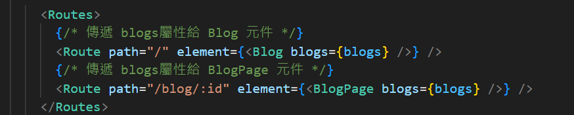

完整BlogPage.jsx程式碼:

import { useParams } from "react-router-dom";

import { Navbar } from "../components";

const BlogPage = ({ blogs }) => {

  const { id } = useParams(); // 獲取動態參數 id

  const blog = blogs.find((b) => b.id === parseInt(id));

  if (!blog) {

    return <div>Blog not found</div>;

  }

  return (

    <div className="p-8">

      <Navbar />

      <img

        className="h-56 w-full object-cover mb-4"

        src={blog.coverImg}

        alt={`Cover for ${blog.title}`}/>

      <h1 className="font-bold text-3xl mb-2">{blog.title}</h1>

      <p className="text-black text-lg">{blog.desc}</p>

    </div>

  );

};

export default BlogPage;

輸出:

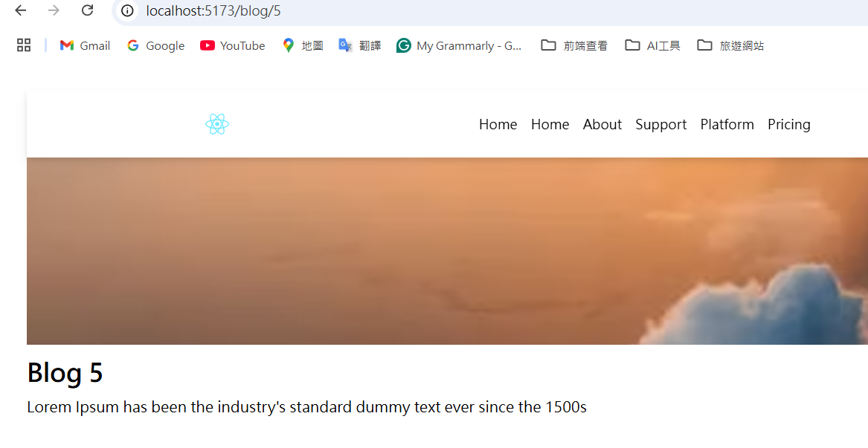

修正程式碼:

因為首頁沒有出現Navbar原因在於App.jsx是傳遞Blog元件blogs屬性，而不是傳遞給HomePage元件。

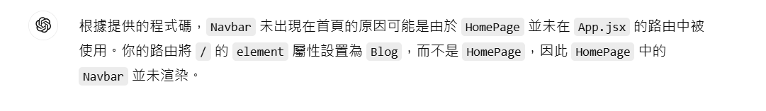

修改後App.jsx完整程式碼:

import { Routes, Route } from "react-router-dom"

import BlogPage from "./pages/BlogPage"

import Blog from "./components/Blog"

import HomePage from "./pages/HomePage";

function App() {

  const blogs = [

    {

      id: 1,

      title: "Blog 1",

      desc: "Lorem Ipsum has been the industry's standard dummy text ever since the 1500s",

      coverImg:

        "https://images.unsplash.com/photo-1500835556837-99ac94a94552?w=500&auto=format&fit=crop&q=60&ixlib=rb-4.0.3&ixid=M3wxMjA3fDB8MHxzZWFyY2h8M3x8dHJhdmVsfGVufDB8fDB8fHww",

    },

    {

      id: 2,

      title: "Blog 2",

      desc: "Lorem Ipsum has been the industry's standard dummy text ever since the 1500s",

      coverImg:

        "https://images.unsplash.com/photo-1500835556837-99ac94a94552?w=500&auto=format&fit=crop&q=60&ixlib=rb-4.0.3&ixid=M3wxMjA3fDB8MHxzZWFyY2h8M3x8dHJhdmVsfGVufDB8fDB8fHww",

    },

    {

        id: 3,

        title: "Blog 3",

        desc: "Lorem Ipsum has been the industry's standard dummy text ever since the 1500s",

        coverImg:

          "https://images.unsplash.com/photo-1500835556837-99ac94a94552?w=500&auto=format&fit=crop&q=60&ixlib=rb-4.0.3&ixid=M3wxMjA3fDB8MHxzZWFyY2h8M3x8dHJhdmVsfGVufDB8fDB8fHww",

      },

      {

        id: 4,

        title: "Blog 4",

        desc: "Lorem Ipsum has been the industry's standard dummy text ever since the 1500s",

        coverImg:

          "https://images.unsplash.com/photo-1500835556837-99ac94a94552?w=500&auto=format&fit=crop&q=60&ixlib=rb-4.0.3&ixid=M3wxMjA3fDB8MHxzZWFyY2h8M3x8dHJhdmVsfGVufDB8fDB8fHww",

      },

      {

        id: 5,

        title: "Blog 5",

        desc: "Lorem Ipsum has been the industry's standard dummy text ever since the 1500s",

        coverImg:

          "https://images.unsplash.com/photo-1500835556837-99ac94a94552?w=500&auto=format&fit=crop&q=60&ixlib=rb-4.0.3&ixid=M3wxMjA3fDB8MHxzZWFyY2h8M3x8dHJhdmVsfGVufDB8fDB8fHww",

      },

      {

        id: 6,

        title: "Blog 6",

        desc: "Lorem Ipsum has been the industry's standard dummy text ever since the 1500s",

        coverImg:

          "https://images.unsplash.com/photo-1500835556837-99ac94a94552?w=500&auto=format&fit=crop&q=60&ixlib=rb-4.0.3&ixid=M3wxMjA3fDB8MHxzZWFyY2h8M3x8dHJhdmVsfGVufDB8fDB8fHww",

      },

  ];

  return (

    <>

      <Routes>

        {/* 傳遞 blogs屬性給 Blog 元件 */}

        <Route path="/" element={<HomePage blogs={blogs} />} />

        {/* 傳遞 blogs屬性給 BlogPage 元件 */}

        <Route path="/blog/:id" element={<BlogPage blogs={blogs} />} />

      </Routes>

    </>

  )

}

export default App

完整HomePage程式碼:

接收app.jsx傳來的blogs變數

import { Blog,   Navbar, StaticLogo,    } from "../components"

import DynamicLogo from "../components/DynamicLogo"

 const HomePage = ({blogs}) => {

   return (

     <div>

        <Navbar />

        <Blog blogs={blogs}/>

        <StaticLogo />

        <DynamicLogo />

     </div>

   )

 }

 export default HomePage

開啟strapi的介面

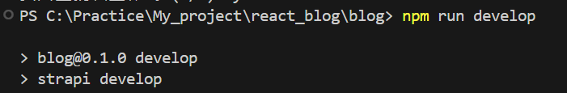



選content-type builder

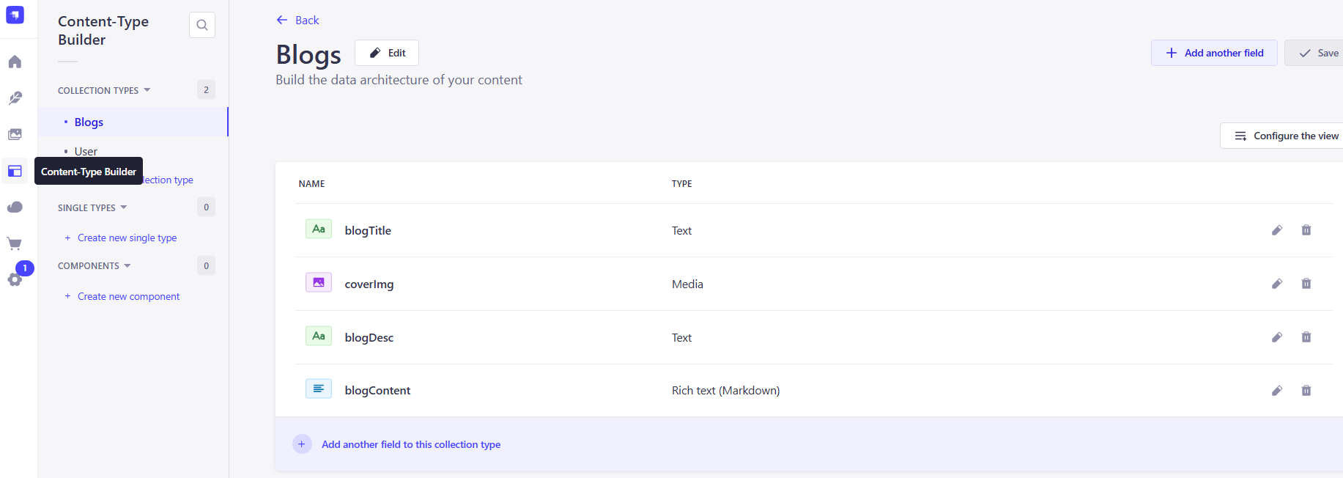

選contentManager，點擊中間的create new entry編輯內容

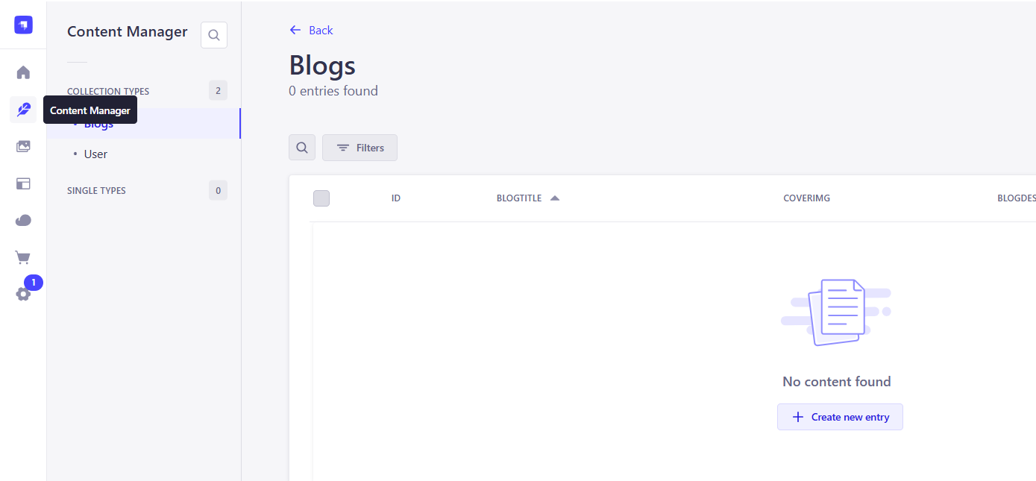

輸入完成資訊之後選publish

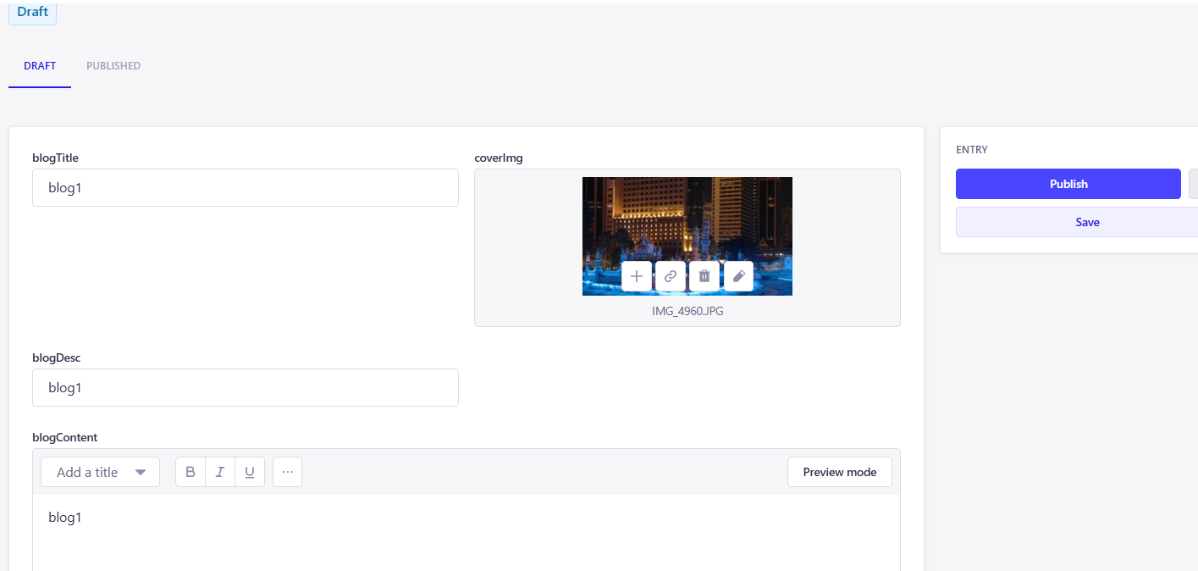

選users & permissions內的Roles

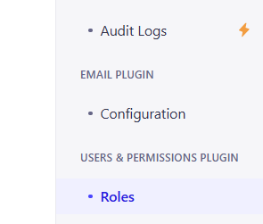

選public 右邊的Edit

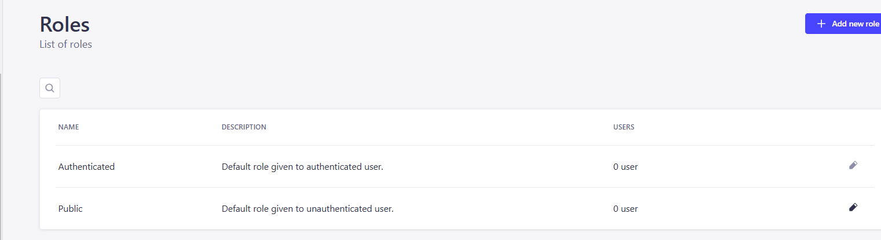

選到建立的Blog打勾允許新增、讀取、更新、刪除

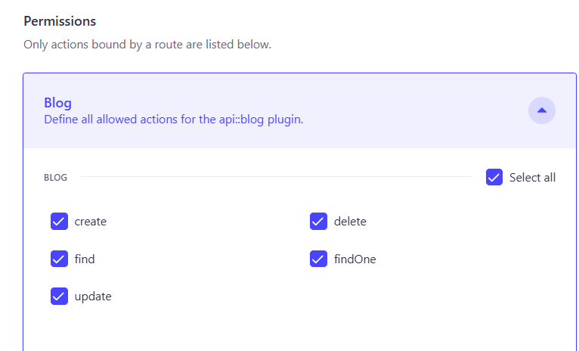

Save儲存

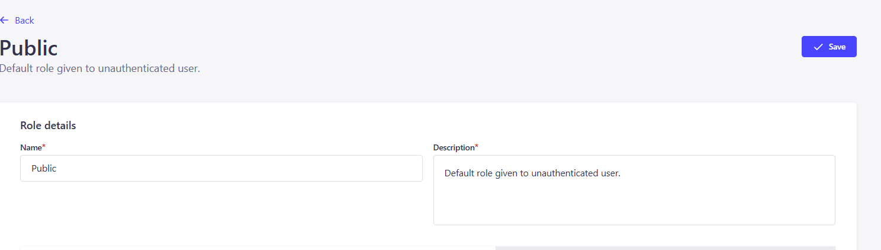

輸入url網址



抓取到Blogs的Collection types

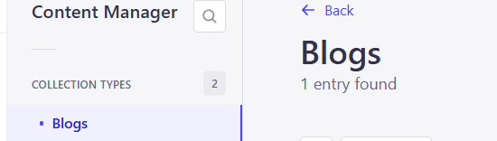

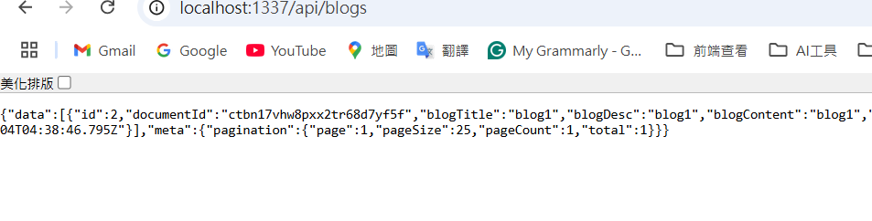

使用hook來抓取Strapi的Api資料

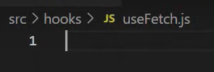

完整程式碼:

import {useEffect, useState} from 'react';

const FetchApi = (url) => {

    const [data,setData] =useState(null)

    const [error,setError] =useState(null)

    const [loading,setLoading] =useState(true)

    useEffect(() => {

        const fetchData = async ()=>{

            setLoading(true)

            try {

                const res = await fetch(url)

                const json = await res.json()

                setData(json)

                setLoading(false)

            } catch (error) {

                setError(error)

                setLoading(false)

            }

        }

        fetchData()

    }, [url])

  return {loading, error, data}

}

export default FetchApi

抓取strapi路徑api的blogs路徑

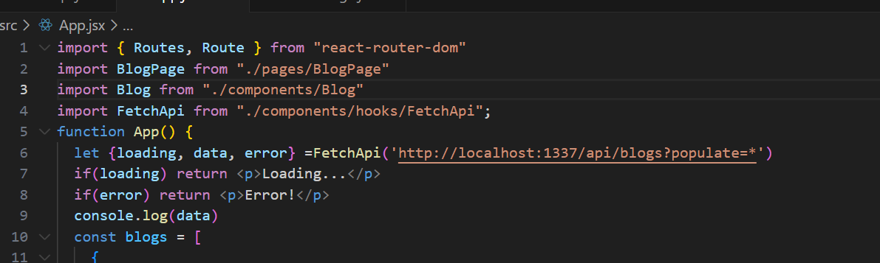

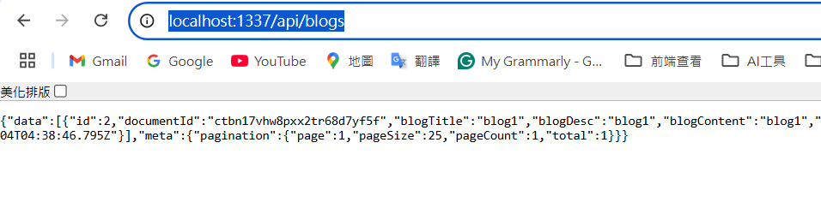

Console檢查確認有沒有抓到strapi的api資料。

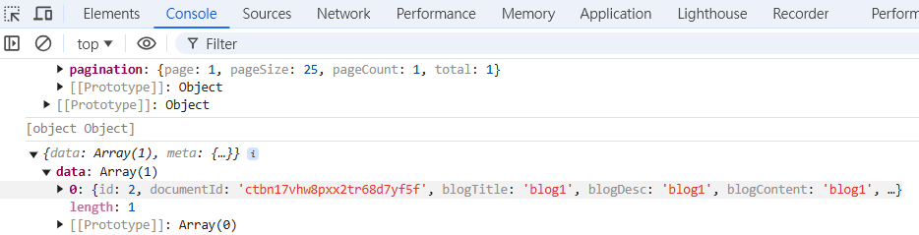

ChatGpt修改程式碼:



App.jsx完整程式碼:

import { Routes, Route } from "react-router-dom";

import BlogPage from "./pages/BlogPage";

import HomePage from "./pages/HomePage";

import FetchApi from "./components/hooks/FetchApi";

function App() {

const { loading, data, error } = FetchApi("http://localhost:1337/api/blogs?populate=*");

if (loading) return <p>Loading...</p>;

if (error) return <p>Error!</p>;

return (

<>

<Routes>

{/* 傳遞 blogs 屬性給 HomePage 元件 */}

<Route path="/" element={<HomePage blogs={data || { data: [] }} />} />

{/* 傳遞 blogs 屬性給 BlogPage 元件 */}

<Route path="/blog/:id" element={<BlogPage blogs={data || { data: [] }} />} />

</Routes>

</>

);

}

export default App;

HomePage.jsx完整程式碼:

import { Blog, Navbar, StaticLogo } from "../components";

import DynamicLogo from "../components/DynamicLogo";

const HomePage = ({ blogs }) => {

return (

<div>

<Navbar />

<Blog blogs={blogs} />

<StaticLogo />

<DynamicLogo />

</div>

);

};

export default HomePage;

Blog.jsx完整程式碼:

import { Link } from "react-router-dom";

const Blog = ({ blogs }) => {

if (!blogs || !blogs.data) {

return <p>No blogs available</p>;

}

return (

<div className="w-full bg-[#ece2e28f] py-[50px]">

<div className="max-w-[1240px] mx-auto">

<div className="grid lg:grid-cols-3 md:grid-cols-2 sm:grid-cols-2 gap-8 px-4 text-black">

{blogs.data.map((blog) => {

const { id, blogTitle, blogDesc, coverImg } = blog; // 提取對應屬性

const coverImgUrl = coverImg?.url

? `http://localhost:1337${coverImg.url}` // 確保是完整的圖片 URL

: "https://via.placeholder.com/150";

return (

<Link to={`/blog/${id}`} key={id}>

<div className="bg-white rounded-xl overflow-hidden drop-shadow-md">

<img

className="h-56 w-full object-cover"

src={coverImgUrl}

alt={`Cover for ${blogTitle || "Untitled Blog"}`}

/>

<div className="p-8">

<h2 className="font-bold text-2xl my-1">{blogTitle || "Untitled"}</h2>

<p className="text-black text-sm">{blogDesc || "No description available"}</p>

</div>

</div>

</Link>

);

})}

</div>

</div>

</div>

);

};

export default Blog;

BlogPage.jsx完整程式碼:

import { useParams } from "react-router-dom";

const BlogPage = ({ blogs }) => {

const { id } = useParams();

const blog = blogs?.data?.find((blog) => blog.id === parseInt(id));

if (!blog) {

return <p>Blog not found</p>;

}

const { blogTitle, blogDesc, coverImg } = blog;

const coverImgUrl = coverImg?.url

? `http://localhost:1337${coverImg.url}` // 確保是完整的圖片 URL

: "https://via.placeholder.com/150";

return (

<div className="max-w-[1240px] mx-auto py-8">

<h1 className="text-4xl font-bold mb-4">{blogTitle || "Untitled"}</h1>

<img className="w-full object-cover mb-4" src={coverImgUrl} alt={`Cover for ${blogTitle}`} />

<p>{blogDesc || "No description available"}</p>

</div>

);

};

export default BlogPage;

FetchApi.js完整程式碼:

import { useState, useEffect } from "react";

const FetchApi = (url) => {

  const [data, setData] = useState(null);

  const [loading, setLoading] = useState(true);

  const [error, setError] = useState(null);

  useEffect(() => {

    const fetchData = async () => {

      try {

        const response = await fetch(url);

        if (!response.ok) {

          throw new Error("Failed to fetch");

        }

        const result = await response.json();

        setData(result);

      } catch (err) {

        setError(err.message);

      } finally {

        setLoading(false);

      }

    };

    fetchData();

  }, [url]);

  return { data, loading, error };

};

export default FetchApi;

成功把在strapi所新增的文字和圖片渲染在前端畫面:

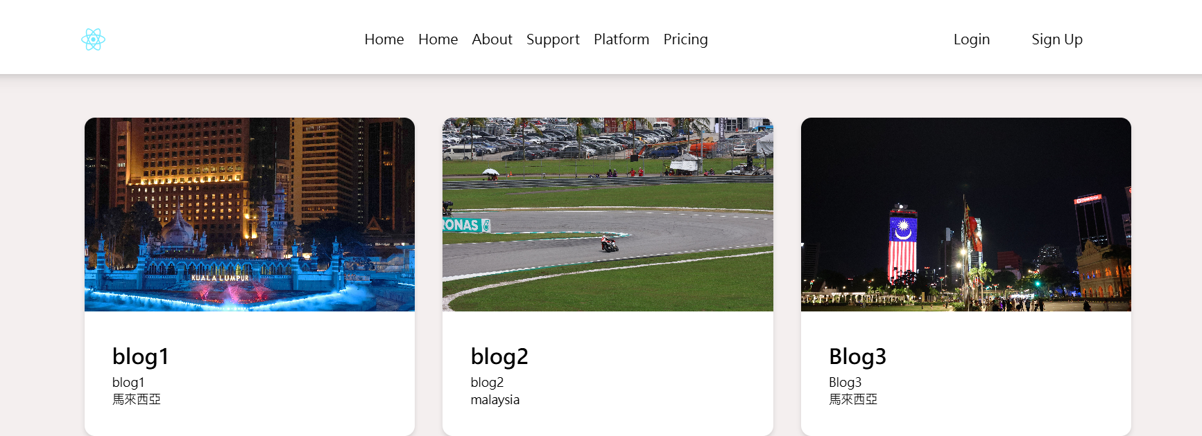

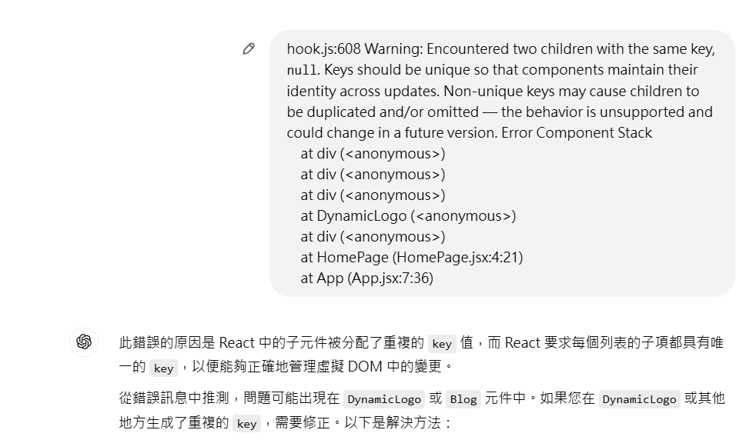 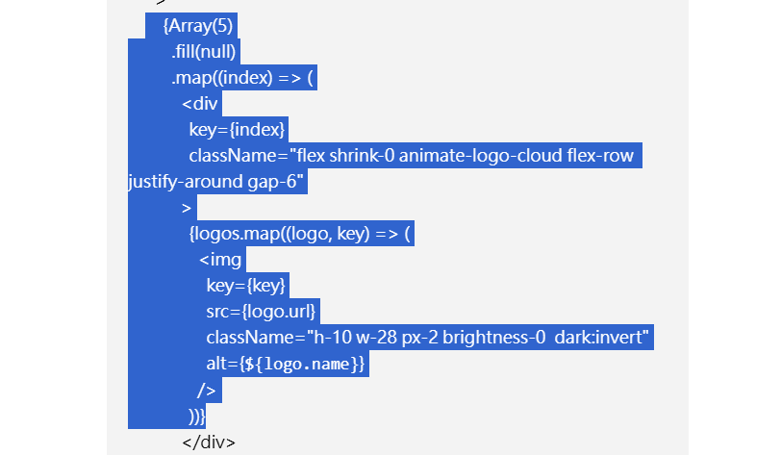

修改後的DynamicLogo.jsx

const DynamicLogo = () => {

const logos = [

{

name: 'Vercel',

url: 'https://res.cloudinary.com/dfhp33ufc/image/upload/v1715881430/vercel_wordmark_dark_mhv8u8.svg',

},

{

name: 'Nextjs',

url: 'https://res.cloudinary.com/dfhp33ufc/image/upload/v1715881475/nextjs_logo_dark_gfkf8m.svg',

},

{

name: 'Prime',

url: 'https://res.cloudinary.com/dfhp33ufc/image/upload/v1715276558/logos/t2awrrfzdvmg1chnzyfr.svg',

},

{

name: 'Trustpilot',

url: 'https://res.cloudinary.com/dfhp33ufc/image/upload/v1715276558/logos/tkfspxqmjflfllbuqxsi.svg',

},

{

name: 'Webflow',

url: 'https://res.cloudinary.com/dfhp33ufc/image/upload/v1715276560/logos/nymiivu48d5lywhf9rpf.svg',

},

{

name: 'Airbnb',

url: 'https://res.cloudinary.com/dfhp33ufc/image/upload/v1715276558/logos/pmblusboe7vkw8vxdknx.svg',

},

{

name: 'Tina',

url: 'https://res.cloudinary.com/dfhp33ufc/image/upload/v1715276560/logos/afqhiygywyphuou6xtxc.svg',

},

{

name: 'Stackoverflow',

url: 'https://res.cloudinary.com/dfhp33ufc/image/upload/v1715276558/logos/ts1j4mkooxqmscgptafa.svg',

},

{

name: 'mistral',

url: 'https://res.cloudinary.com/dfhp33ufc/image/upload/v1715276558/logos/tyos2ayezryjskox3wzs.svg',

},

];

return (

<div className="w-full py-12">

<div className="mx-auto w-full px-4 md:px-8">

<div

className="group relative mt-6 flex gap-6 overflow-hidden p-2"

style={{

maskImage:

'linear-gradient(to left, transparent 0%, black 20%, black 80%, transparent 95%)',

}}

>

{Array(5)

.fill(null)

.map((_, outerIndex) => (

<div

key={`logo-group-${outerIndex}`}

className="flex shrink-0 animate-logo-cloud flex-row justify-around gap-6"

>

{logos.map((logo, innerIndex) => (

<img

key={`${outerIndex}-${innerIndex}`}

src={logo.url}

className="h-10 w-28 px-2 brightness-0 dark:invert"

alt={`${logo.name}`}

/>

))}

</div>

))}

</div>

</div>

</div>

);

};

export default DynamicLogo; 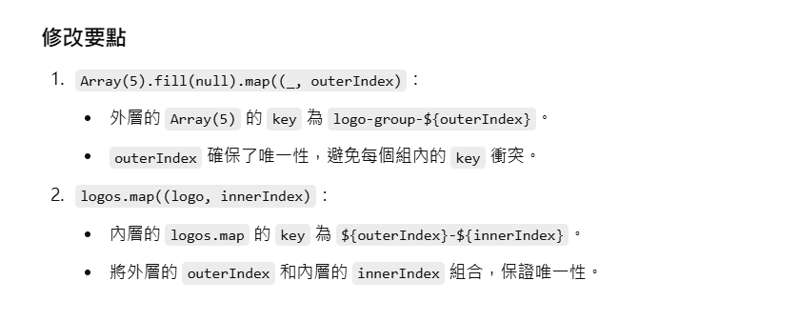

假設我想在首頁再新增圖片和title和新的filed

先輸入指令:



選content manager

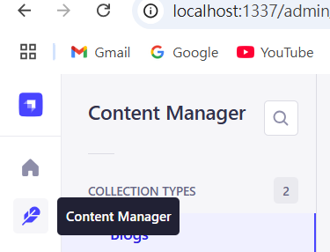

右邊建立new entry



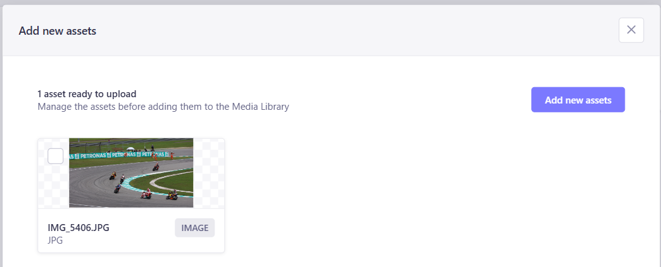

Update完成之後finish

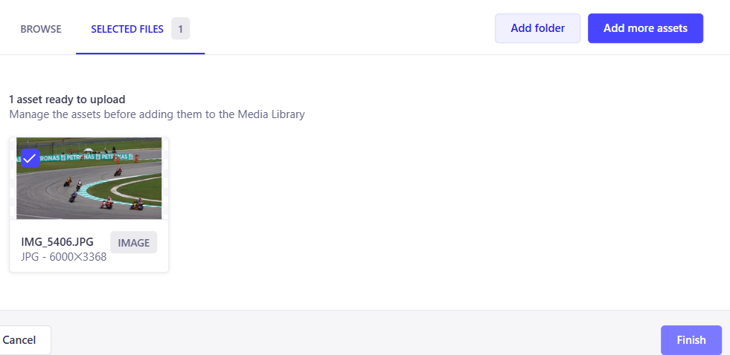 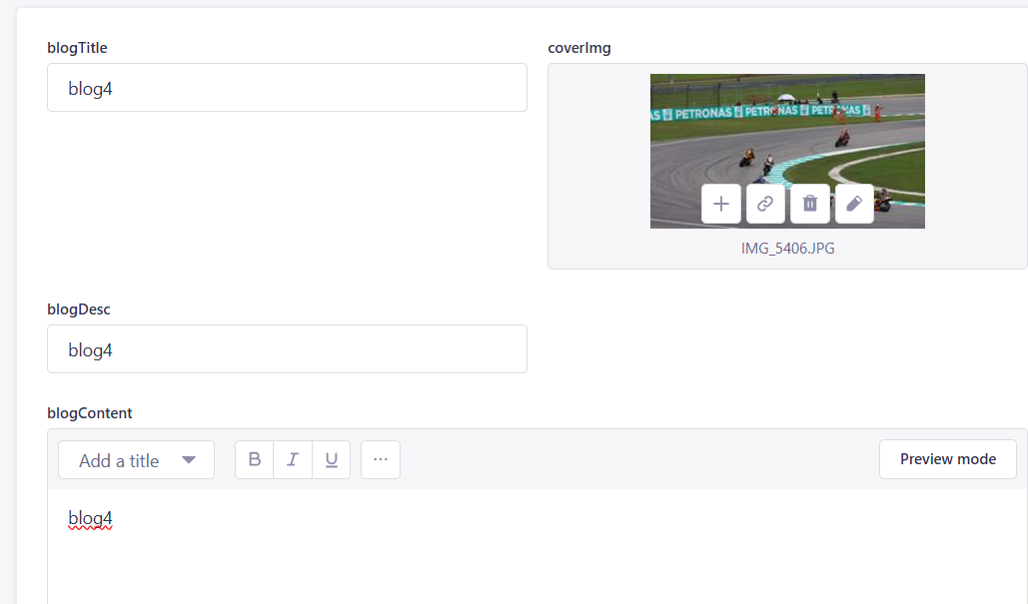

確認之後publish

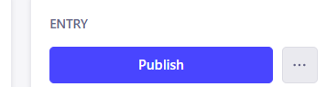

成功新增blog4渲染在前端畫面

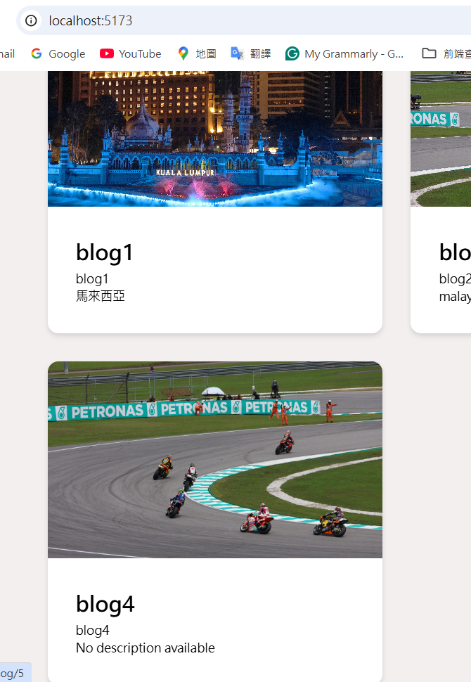

新增內容屬性的話選content-type Builder，點右邊的add another field

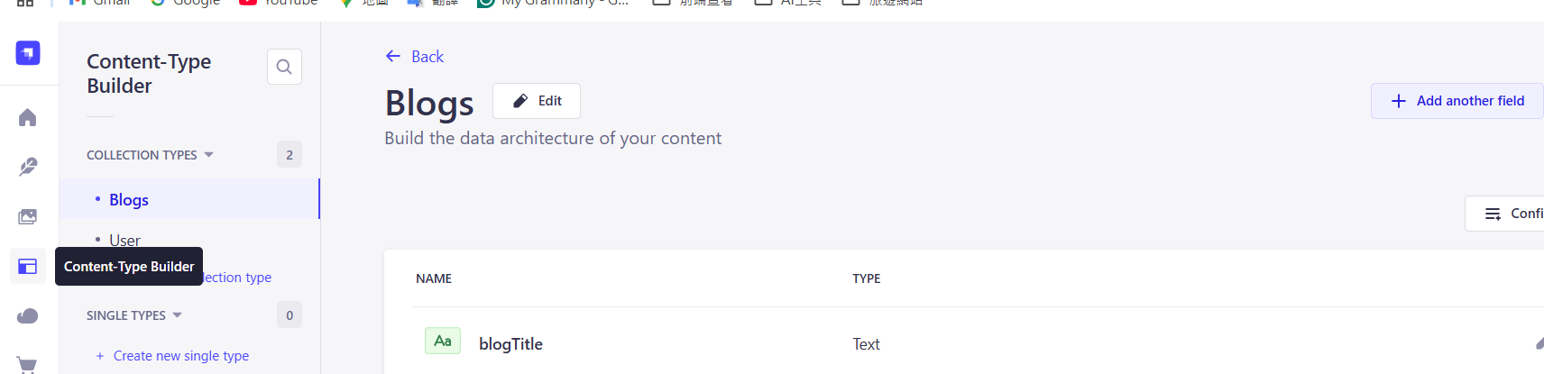 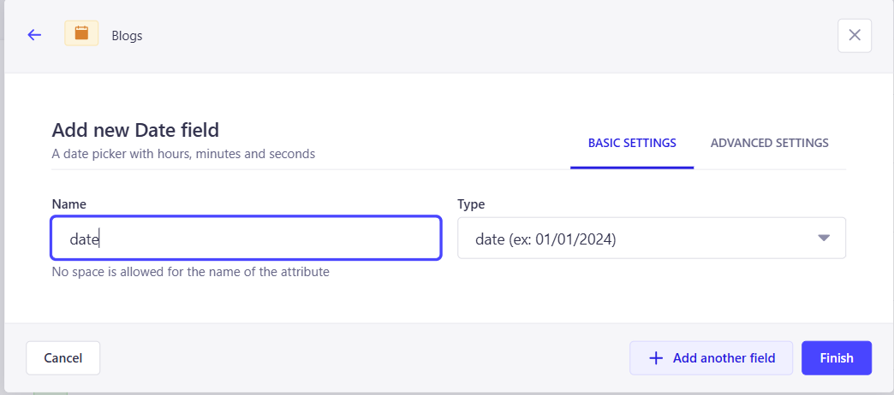

回到Content manager，出現剛剛在builder出現的date

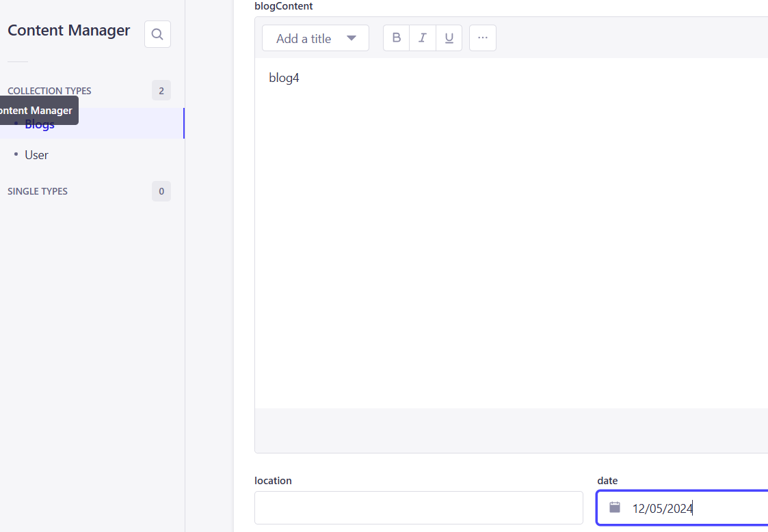

回到程式碼Blog和BlogPage元件新增date屬性

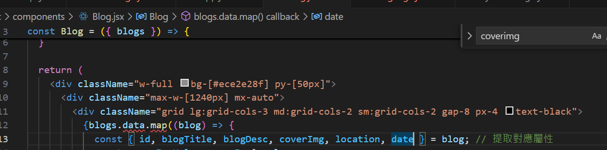

在return後面渲染

